**Statistical Foundations of Data Science and their Applications**

**A conference in celebration of Jianqing Fan's 60th Birthday**

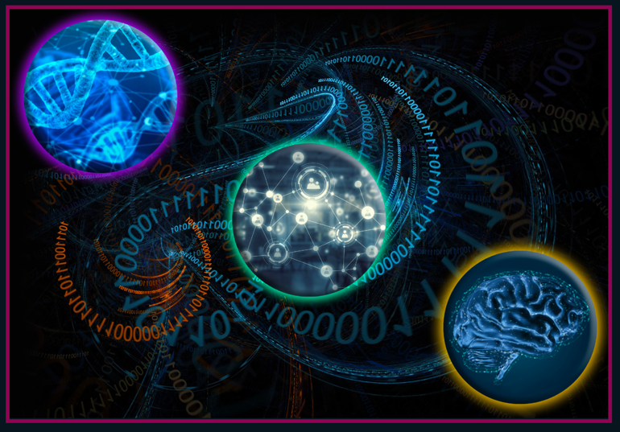

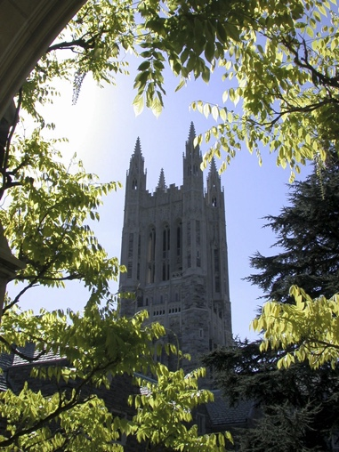

**Princeton, May 8-10, 2023**

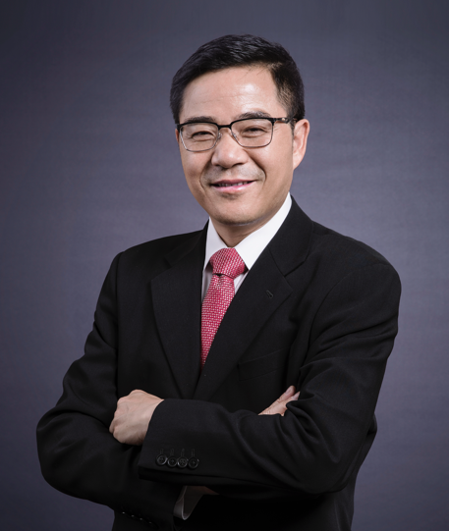

## **Sponsorship & Support**

[Department of Operations Research & Financial Engineering](https://orfe.princeton.edu/)  (ORFE), Princeton University

[Department of Statistics](https://science.psu.edu/stat), Pennsylvania State University at University Park

[Department of Data Sciences and Operations](https://www.marshall.usc.edu/departments/data-sciences-and-operations), University of Southern California (USC)

[Department of Economics](https://economics.princeton.edu/), Princeton University

[Department of Mathematics](https://www.imperial.ac.uk/mathematics/), Imperial College London

[Center for Statistics and Machine Learning](https://csml.princeton.edu/) (CSML), Princeton University

[Program in Applied and Computational Mathematics](https://www.pacm.princeton.edu/) (PACM), Princeton University

[Bendheim Center for Finance](https://bcf.princeton.edu) (BCF), Princeton University

[Center on Contemporary China](https://ccc.princeton.edu/), Princeton University

[National Science Foundation](https://www.nsf.gov/awardsearch/showAward?AWD_ID=2304646) (NSF)

[Institute of Mathematical Statistics](https://imstat.org/) (IMS)

[American Statistical Association](https://www.amstat.org/) (ASA)

[International Chinese Statistical Association](https://www.icsa.org/) (ICSA)

[Two Sigma](https://www.twosigma.com/)

[Hudson Bay Capital](https://www.hudsonbaycapital.com)

Wizard Capital Research Limited, Hong Kong

## **Local Organizing Committee**

* Matias D. Cattaneo (Chair), Princeton University
* Yacine Ait-Sahalia, Princeton University
* Rajita Chandak, Princeton University
* Sohom Bhattacharya, Princeton University
* Debarghya Mukherjee, Princeton University
* William Underwood, Princeton University
* Bingyan Wang, Princeton University
* Yuling Yan, Princeton University
* Mengxin Yu, Princeton University

## **Program Committee**

* Runze Li (Chair), Pennsylvania State University
* Heather Battey, Imperial College London
* Jelena Bradic, University of California at San Diego
* Matias D. Cattaneo, Princeton University
* Ming-Yen Cheng, Hong Kong Baptist University
* Yingying Fan, University of Southern California
* Tracy Ke, Harvard University
* Dacheng Xiu, University of Chicago
* Wenyang Zhang, University of York (UK)

## **Banquet Activity Organizing Committee**

* Tracy Ke (Chair), Harvard University
* Zhao Chen, Fudan University
* Yang Feng, New York University
* Runze Li, Pennsylvania State University
* Yue Niu, University of Arizona
* Xin Tong, University of Southern California
* Weichen Wang, University of Hong Kong
* Bingyan Wang, Princeton University
* Yuyan Wang, Google Inc
* Lucy Xia, Hong Kong University of Science and Technology
* Lingzhou Xue, Pennsylvania State University
* Yuling Yan, Princeton University
* Zhengjun Zhang, University of Chinese Academy of Sciences

**Practical Information**

## Local Lodging & Visitor Links

* [Lodging](https://www.visitprinceton.org/hotels/)
* [Visiting Princeton](https://www.princeton.edu/meet-princeton/visit-us)

## Campus Parking & Transportation

All registrants should park in the [Stadium Drive Garage](https://m.princeton.edu/default/map/index?_recenter=true&_maptab=browse&feed=campus_map&id=_5124&parentId=campus_map%2FParking)

 ([Google Maps](https://goo.gl/maps/JUBeqBBDkuEgEyMy6), [Apple Maps](https://maps.apple.com/?address=249%20Fitzrandolph%20Rd,%20Princeton,%20NJ%20%2008540,%20United%20States&auid=9626517077402789084&ll=40.345168,-74.644889&lsp=9902&q=Stadium%20Drive%20Garage)) for the day with a parking permit, required between 8am and 5pm. **The link for the permit will be sent in an email to all registered participants who indicated they will be driving to campus.**  
   
Guests can board the [Tiger Transit Shuttle](https://transportation.princeton.edu/getting-around/tigertransit/routes-schedules) (Route #1 or #4) at the garage and be dropped off at McCosh walk stop (Robertson side) – below are the scheduled times of boarding and drop off, or [see today's real-time bus location and schedule](https://princeton.tripshot.com)

### From the Garage

If additional shuttle times are needed, please download the timetables or see the [Transportation & Parking Services site](https://transportation.princeton.edu) for more information.

[Download the Complete Timetable From the Garage](https://transportation.princeton.edu/sites/g/files/toruqf611/files/documents/routes-from-stadium-drive-garage.pdf)

### To the Garage

After the conference, guests should walk to McCosh Walk stop and wait on the Southbound side (Wooten side) – below are the times & bus numbers. Multiple buses stop at McCosh, but only #1 and #2 stop at the Stadium Dr garage – guests can confirm with the driver if unsure.

[Download the Complete Timetable from McCosh to the Garage](https://transportation.princeton.edu/sites/g/files/toruqf611/files/documents/routes-to-stadium-drive-garage.pdf)

**Table of Contents**

* 1. Sponsorship and Support………………………………………………………...3
  2. Local Organizing Committee…………………………………………………….3
  3. Program Committee……………………………………………………………...4
  4. Banquet Activity Organizing Committee………………………………………..4
  5. Practical Information…………………………………………………………….5
  6. Schedule…………………………………………………………………………7
  7. Abstracts of Invited Talks………………………………………………………16
  8. Abstracts of Poster Presentation………………………………………………..28
  9. Invited Speakers and Participants………………………………………………44

# Schedule

## Opening ceremony and all talks for all dates are located in 101 [Friend Center](https://m.princeton.edu/default/map/index?filter=Friend%20Center%20&_recenter=true)

Day 1 (May 8, 2023)

8:00 am – 9:10 am Registration at Friend Center (pick up registration name badges and conference

materials upon arrival to Friend Center)

9:10 am – 9:40 am [Opening Ceremony](https://fan60.princeton.edu/events/2023/opening-ceremony)

Matias Cattaneo (Chair, Local Organizing Committee),

Runze Li (Chair, Program Committee),

Sanjeev Kulkarni (ORFE/ECE, former Dean of the Faculty)

9:40 am – 10:05 am

[Peter Bickel](https://fan60.princeton.edu/events/2023/peter-bickel)

Independence and functional dependence I

Xuming He (Chair)

10:05 am – 10:30 am

[Kosuke Imai](https://fan60.princeton.edu/events/2023/kosuke-imai)

Safe Policy Learning through Extrapolation: Application to Pre-trial Risk Assessment

Xuming He (Chair)

10:30 am – 10:55 am

[Philip A. Ernst](https://fan60.princeton.edu/events/2023/philip-ernst)

New Frontiers in Statistical Inference for Stochastic Processes

Xuming He (Chair)

10:55 am – 11:35 am

[Group Photo at Fountain of Freedom & Break](https://fan60.princeton.edu/events/2023/group-photo-break)

11:35 am – 12:35 pm [Panels 1, 2, & 3](https://fan60.princeton.edu/events/2023/panels-1-2-3)

**Panel 1: Frontier Research on Minimax estimation**  
Friend 004

Florentina Bunea, Harrison Zhou, Zongming Ma, Weijie Su, Bill Strawderman, Linda Zhao (Chair)

**Panel 2: Meet Editors and Department Heads (Junior researcher Career development)**  
Computer Science 104

Gang Li, Annie Qu, Tian Zheng, Dylan Small, Ji Zhu, Liza Levina, Yazhen Wang, Edward George, Minge Xie (Chair)

**Panel 3: Frontier research on optimization in data science**  
Friend 101

Steve Kou, Ethan Fang, Yuxin Chen, Zhaoran Wang, Yao Xie, Lingzhou Xue, Yang Ning, Yaqi Duan (chair)

12:35 pm – 2:00 pm

[Lunch](https://fan60.princeton.edu/events/2023/lunch)

2:00 pm – 2:25 pm

[Yacine Ait-Sahalia](https://fan60.princeton.edu/events/2023/yacine-ait-sahalia)

So Many Jumps, So Few News

Zhiliang Ying (Chair)

2:25 pm – 2:50 pm

[Qiwei Yao](https://fan60.princeton.edu/events/2023/qiwei-yao)

Autoregressive Networks

Zhiliang Ying (Chair)

2:50 pm – 3:15 pm

[Jinchi Lv](https://fan60.princeton.edu/events/2023/jinchi-lv)

SIMPLE-RP: Group Network Inference with Non-Sharp Nulls and Weak Signals

Zhiliang Ying (Chair)

3:15 pm – 3:30 pm

[Break](https://fan60.princeton.edu/events/2023/break)

3:30 pm – 3:55 pm

[Irène Gijbels](https://fan60.princeton.edu/events/2023/ir%C3%A8ne-gijbels)

Circular local likelihood regression

Jiayang Sun (Chair)

3:55 pm – 4:20 pm

[Wenyang Zhang](https://fan60.princeton.edu/events/2023/wenyang-zhang)

A Flexible and Parsimonious Modelling Strategy for Clustered Data Analysis

Jiayang Sun (Chair)

4:20 pm – 4:45 pm

[Ming-Yen Cheng](https://fan60.princeton.edu/events/2023/ming-yen-cheng)

Inference for nonstationary time series with varying periodicity, a smooth trend and covariate effects

Jiayang Sun (Chair)

4:45 pm – 6:15 pm [Poster](https://fan60.princeton.edu/events/2023/poster)

Zhengjun Zhang (Chair)

Location: Friend Center Upper Atrium

Day 2 (May 9, 2023)

8:30 am – 8:55 am

[J. S. Marron](https://fan60.princeton.edu/events/2023/j-s-marron)

Object oriented data analysis

Raymond Carroll (Chair)

8:55 am – 9:20 am

[Wolfgang Härdle](https://fan60.princeton.edu/events/2023/wolfgang-h%C3%A4rdle)

Robustifying Markowitz

Raymond Carroll (Chair)

9:20 am – 9:45 am

[Enno Mammen](https://fan60.princeton.edu/events/2023/enno-mammen)

Random Planted Forest: a directly interpretable tree ensemble

Raymond Carroll (Chair)

9:45 am – 10:00 am

[Break](https://fan60.princeton.edu/events/2023/break)

10:00 am – 10:25 am

[Richard Samworth](https://fan60.princeton.edu/events/2023/richard-samworth)

Optimal nonparametric testing of missing completely at random, and its connections to compatibility

Li-Shan Huang (Chair)

10:25 am – 10:50 am

[Hui Zou](https://fan60.princeton.edu/events/2023/hui-zou)

M-Optimal designs through the lens of modern optimization

Li-Shan Huang (Chair)

10:50 am – 11:15 am

[Heather Battey](https://fan60.princeton.edu/events/2023/heather-battey)

Inducement of population sparsity

Li-Shan Huang (Chair)

11:15 am – 11:30 am

[Break](https://fan60.princeton.edu/events/2023/break)

11:30 am – 12:30 pm [Panels 4, 5, & 6](https://fan60.princeton.edu/events/2023/panels-4-5-6)

**Panel 4: Data Science applications in real world**  
Computer Science 104

Hongtu Zhu, Rui Song, Emre Barut, Lei Qi, Igor Silin, Runlong Tang, Wei Dai (Chair)

**Panel 5: Frontier research on business statistics and Econometrics**  
Friend 004

Zongwu Cai, Elynn Chen, Rong Chen, Weining Wang, Yan Yu, Emma Zhang, Yingying Li, Yongyi Guo (Chair)

**Panel 6: Frontier research on machine learning**  
Friend 101

Edgar Dobriban, Xi Chen, Yuting Wei, Cong Ma, Krishna Balasubramanian, Marco Avella-Medina, Yuejie Chi, Lan Wang, Jelena Bradic, Haolei Weng (Chair)

12:30 pm – 2:00 pm

[Lunch](https://fan60.princeton.edu/events/2023/lunch)

2:00 pm – 2:25 pm

[Hans Mueller](https://fan60.princeton.edu/events/2023/hans-mueller)

Distributional Regression with Optimal Transports

Jin-Ting Zhang (Chair)

2:25 pm – 2:50 pm

[Jane-Ling Wang](https://fan60.princeton.edu/events/2023/jane-ling-wang)

Deep Learning for Partial Linear Cox Model

Jin-Ting Zhang (Chair)

2:50 pm – 3:15 pm

[Chunming Zhang](https://fan60.princeton.edu/events/2023/chunming-zhang)

New statistical learning method for independent component analysis in the presence of noise

Jin-Ting Zhang (Chair)

3:15 pm – 3:30 pm

[Break](https://fan60.princeton.edu/events/2023/break)

3:30 pm – 3:55 pm

[Xihong Lin](https://fan60.princeton.edu/events/2023/xihong-lin)

Fast Distributed Principal Component Analysis for Large-Scale Federated Data

Jiancheng Jiang (Chair)

3:55 pm – 4:20 pm

[Jianwen Cai](https://fan60.princeton.edu/events/2023/jianwen-cai)

Feature screening for case-cohort studies with failure time outcome

Jiancheng Jiang (Chair)

4:20 pm – 4:45 pm

[Kinh Truong](https://fan60.princeton.edu/events/2023/kinh-troung)

On estimating power spectral density for independent component analysis

Jiancheng Jiang (Chair)

4:45 pm – 5:00 pm

[Jennifer Rexford (Provost, Princeton)](https://fan60.princeton.edu/events/2023/jennifer-rexford-provost-princeton)

5:00 pm – 5:15 pm

[Break](https://fan60.princeton.edu/events/2023/break)

5:15 pm – 6:15 pm

[Panels 7, 8, & 9](https://fan60.princeton.edu/events/2023/panels-7-8-9)

**Panel 7: Frontier research on statistical genetics**  
Friend 004

Jun Liu, Haiyan Huang, Jessica Li, Hongyu Zhao (Chair)

**Panel 8: Frontier research on biostatistics**  
Computer Science 104

Ying Lu, Yi Li, Quefeng Li, Ying Wei, Zhezhen Jin, Catherine Liu, Haibo Zhou (Chair)

**Panel 9:  Frontier Research on high-dimensional data modeling**  
Friend 101

Donggyu Kim, Kaizheng Wang, Yuan Ke, Yiqiao Zhong, Weichen Wang, Wenxin Zhou, Qiang Sun, Qiman Shao (Chair)

7:00 pm – 9:00 pm

[Conference dinner](https://fan60.princeton.edu/events/2023/conference-dinner)

Ronnie Sircar (Chair, ORFE)

Location: Frick Chemistry Laboratory

Day 3 (May 10, 2023)

8:30 am – 8:55 am

[Tony Cai](https://fan60.princeton.edu/events/2023/tony-cai)

Optimal Statistical Estimation under Nonstatistical Constraints

Lucy Xia (Chair)

8:55 am – 9:20 am

[Jiashun Jin](https://fan60.princeton.edu/events/2023/jiashun-jin)

The Statistics Triangle

Lucy Xia (Chair)

9:20 am – 9:45 am

[Per Mykland](https://fan60.princeton.edu/events/2023/mykland)

Of Lean Cats, Unsupervised Learning, and Contiguity

Yingying Li (Chair)

9:45 am – 10:10 am

[Marc Hallin](https://fan60.princeton.edu/events/2023/marc-hallin)

Inferential theory for generalized dynamic factor models

Yingying Li (Chair)

10:10 am – 10:30 am

[Break](https://fan60.princeton.edu/events/2023/break)

10:30 am – 10:55 am

[Peter Bühlmann](https://fan60.princeton.edu/events/2023/peter-b%C3%BChlmann)

Invariant!

Xin Tong (Chair)

10:55 am – 11:20 am

[Ming Yuan](https://fan60.princeton.edu/events/2023/ming-yuan)

Statistical Optimality and Computational Tractability of ICA

Xin Tong (Chair)

11:20 am – 11:45 am

[Xiao-Li Meng](https://fan60.princeton.edu/events/2023/xiao-li-meng)

From Gaussianity to Cauchyanity: A Worthwhile Trade-off for (Ultra) High-dimensional Inference?

Yang Feng (Chair)

11:45 am – 12:10 pm

[David Donoho](https://fan60.princeton.edu/events/2023/david-donoho)

ScreeNOT: Exact MSE-Optimal Singular Value Thresholding in Correlated Noise

Yang Feng (Chair)

12:10 pm – 12:30 pm

[Closing remarks](https://fan60.princeton.edu/events/2023/closing-remarks)

12:30 pm – 2:00 pm

[Lunch](https://fan60.princeton.edu/events/2023/lunch)

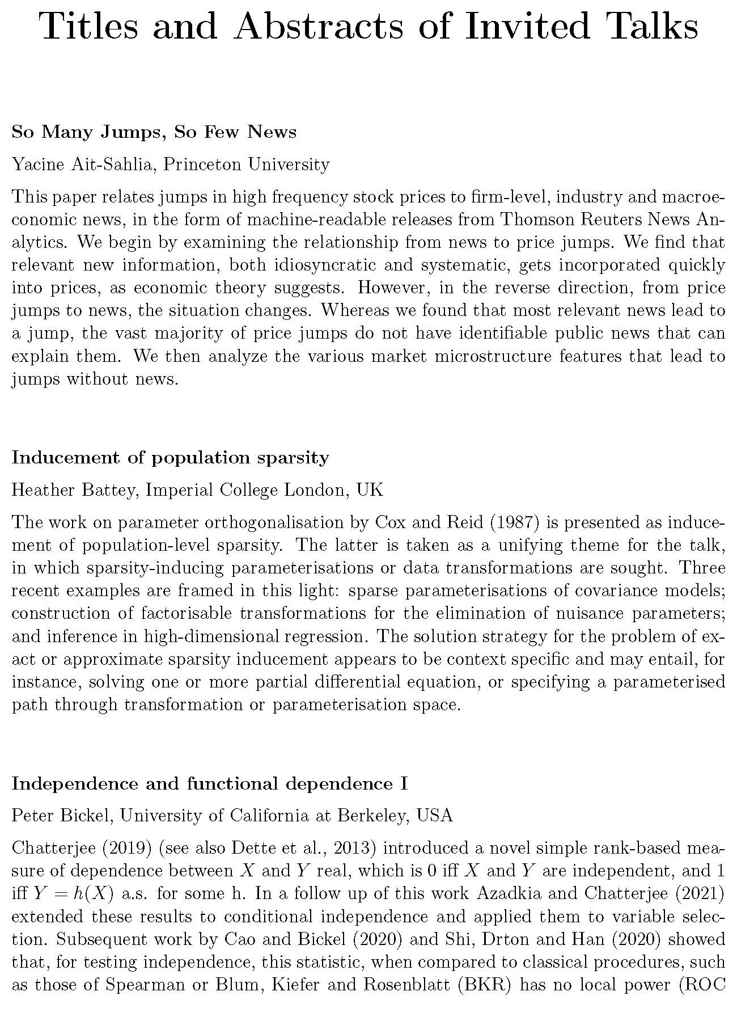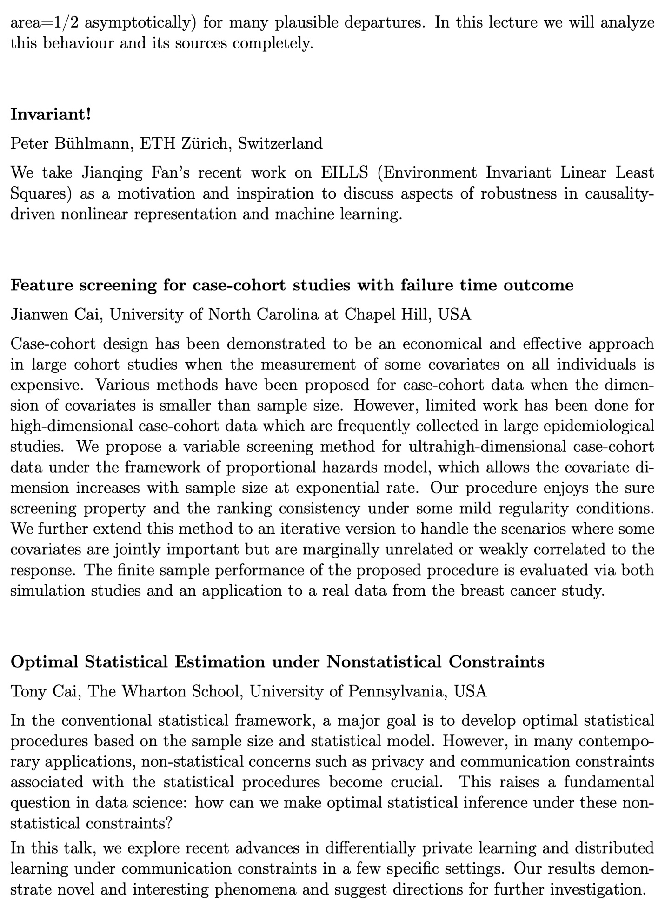

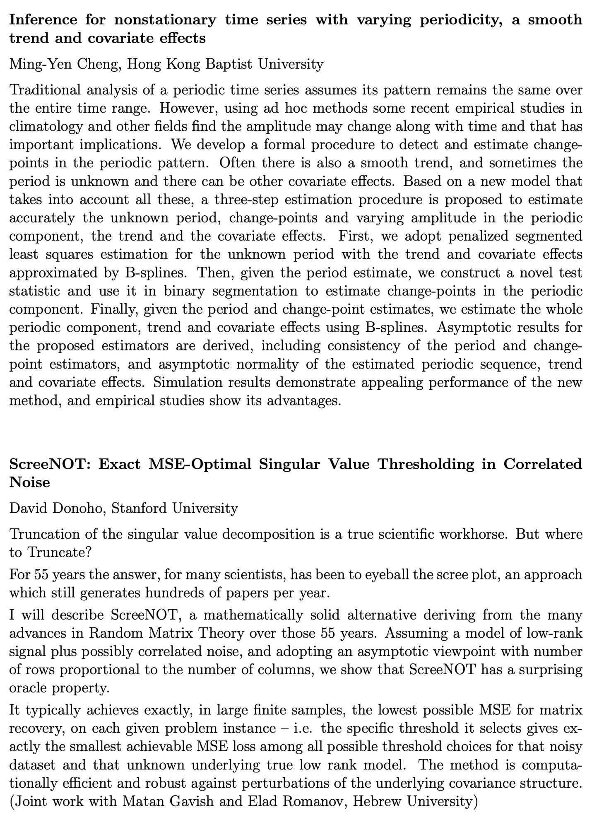

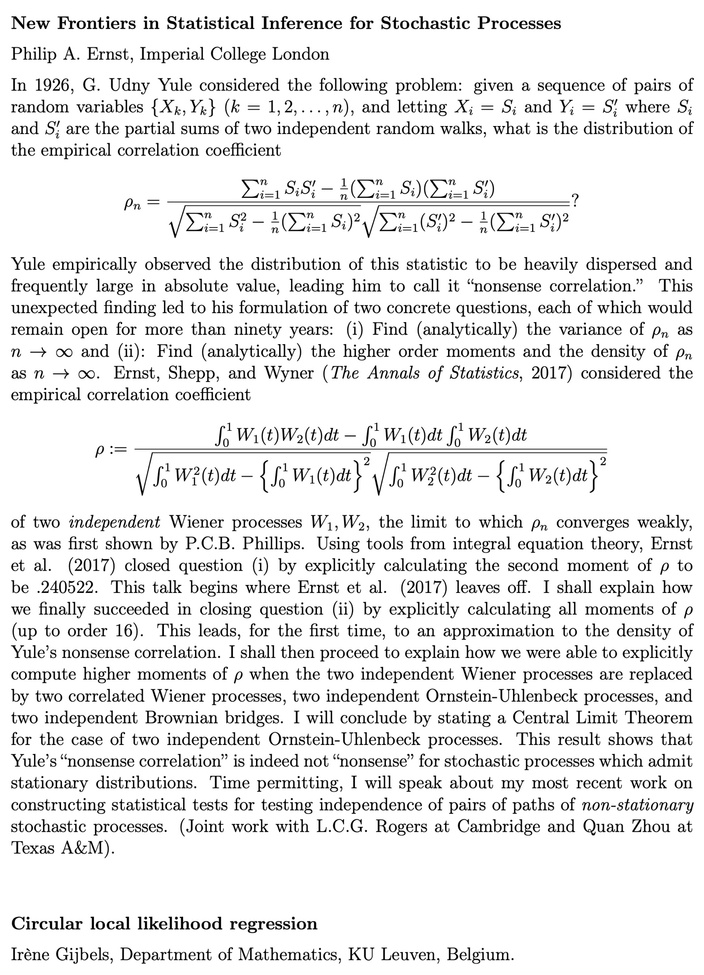

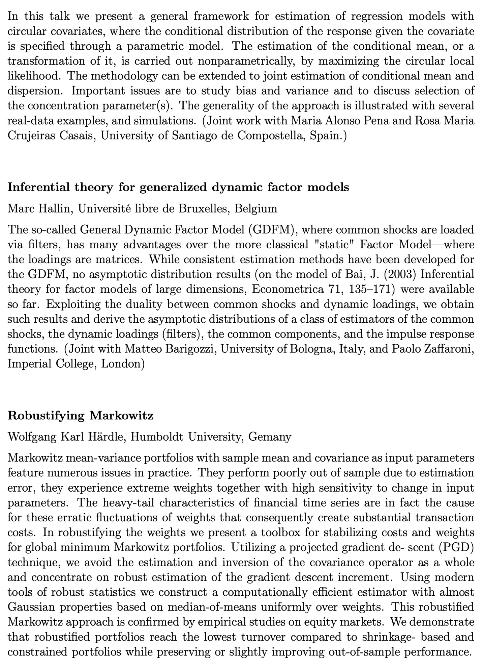

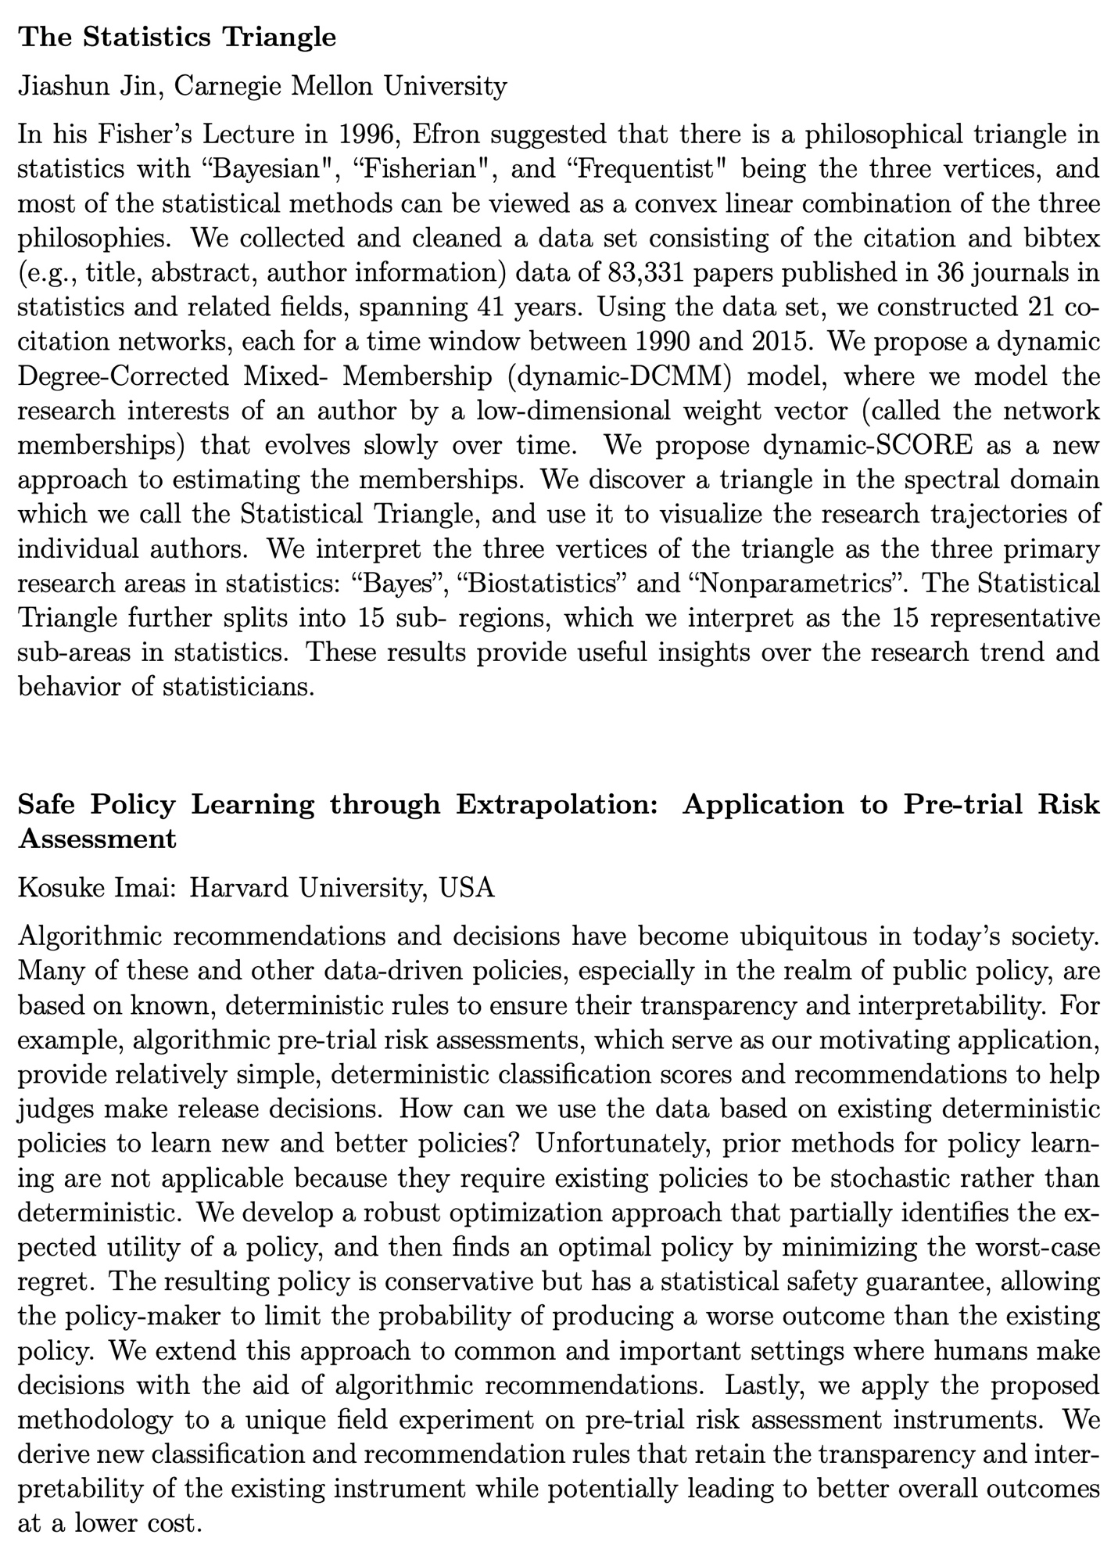

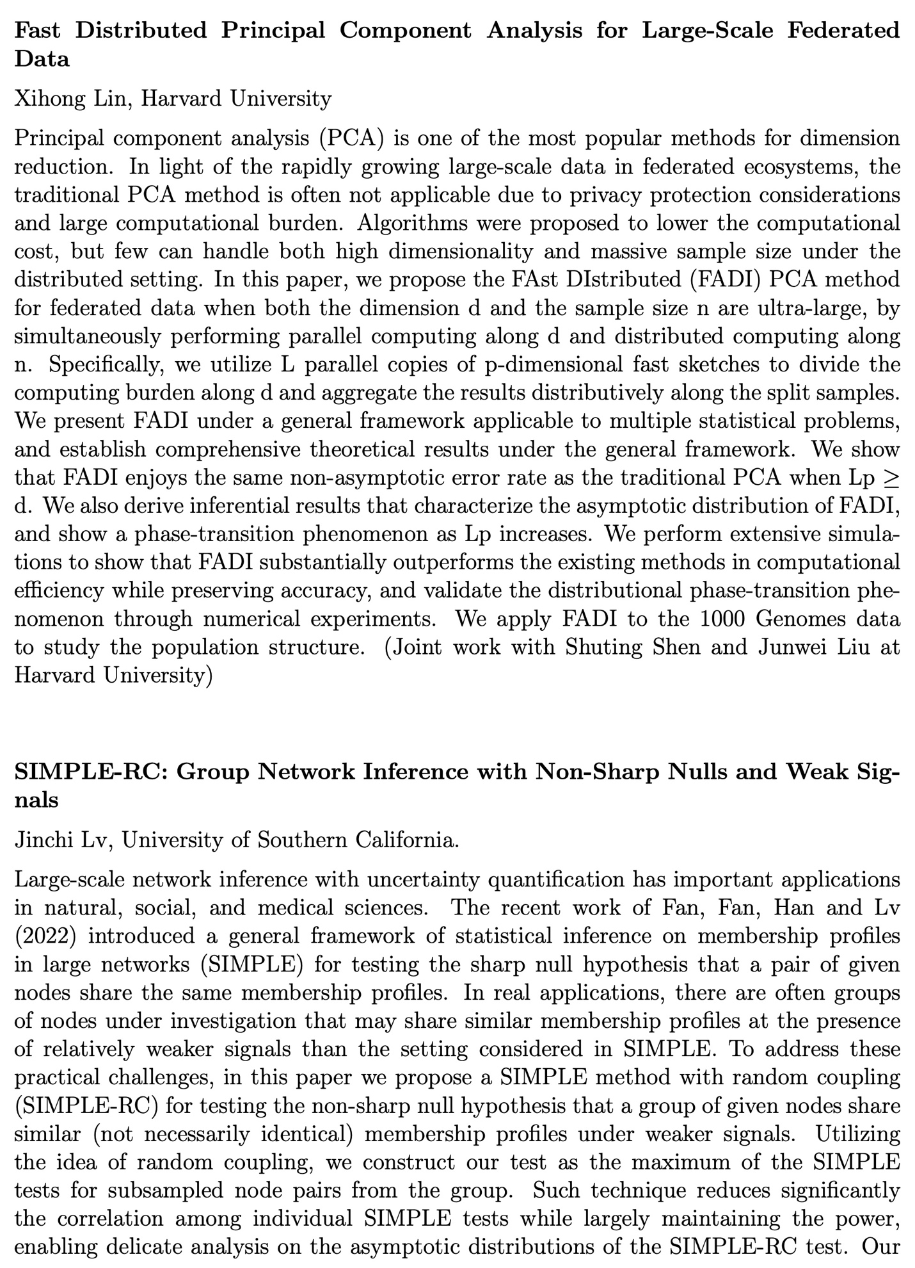

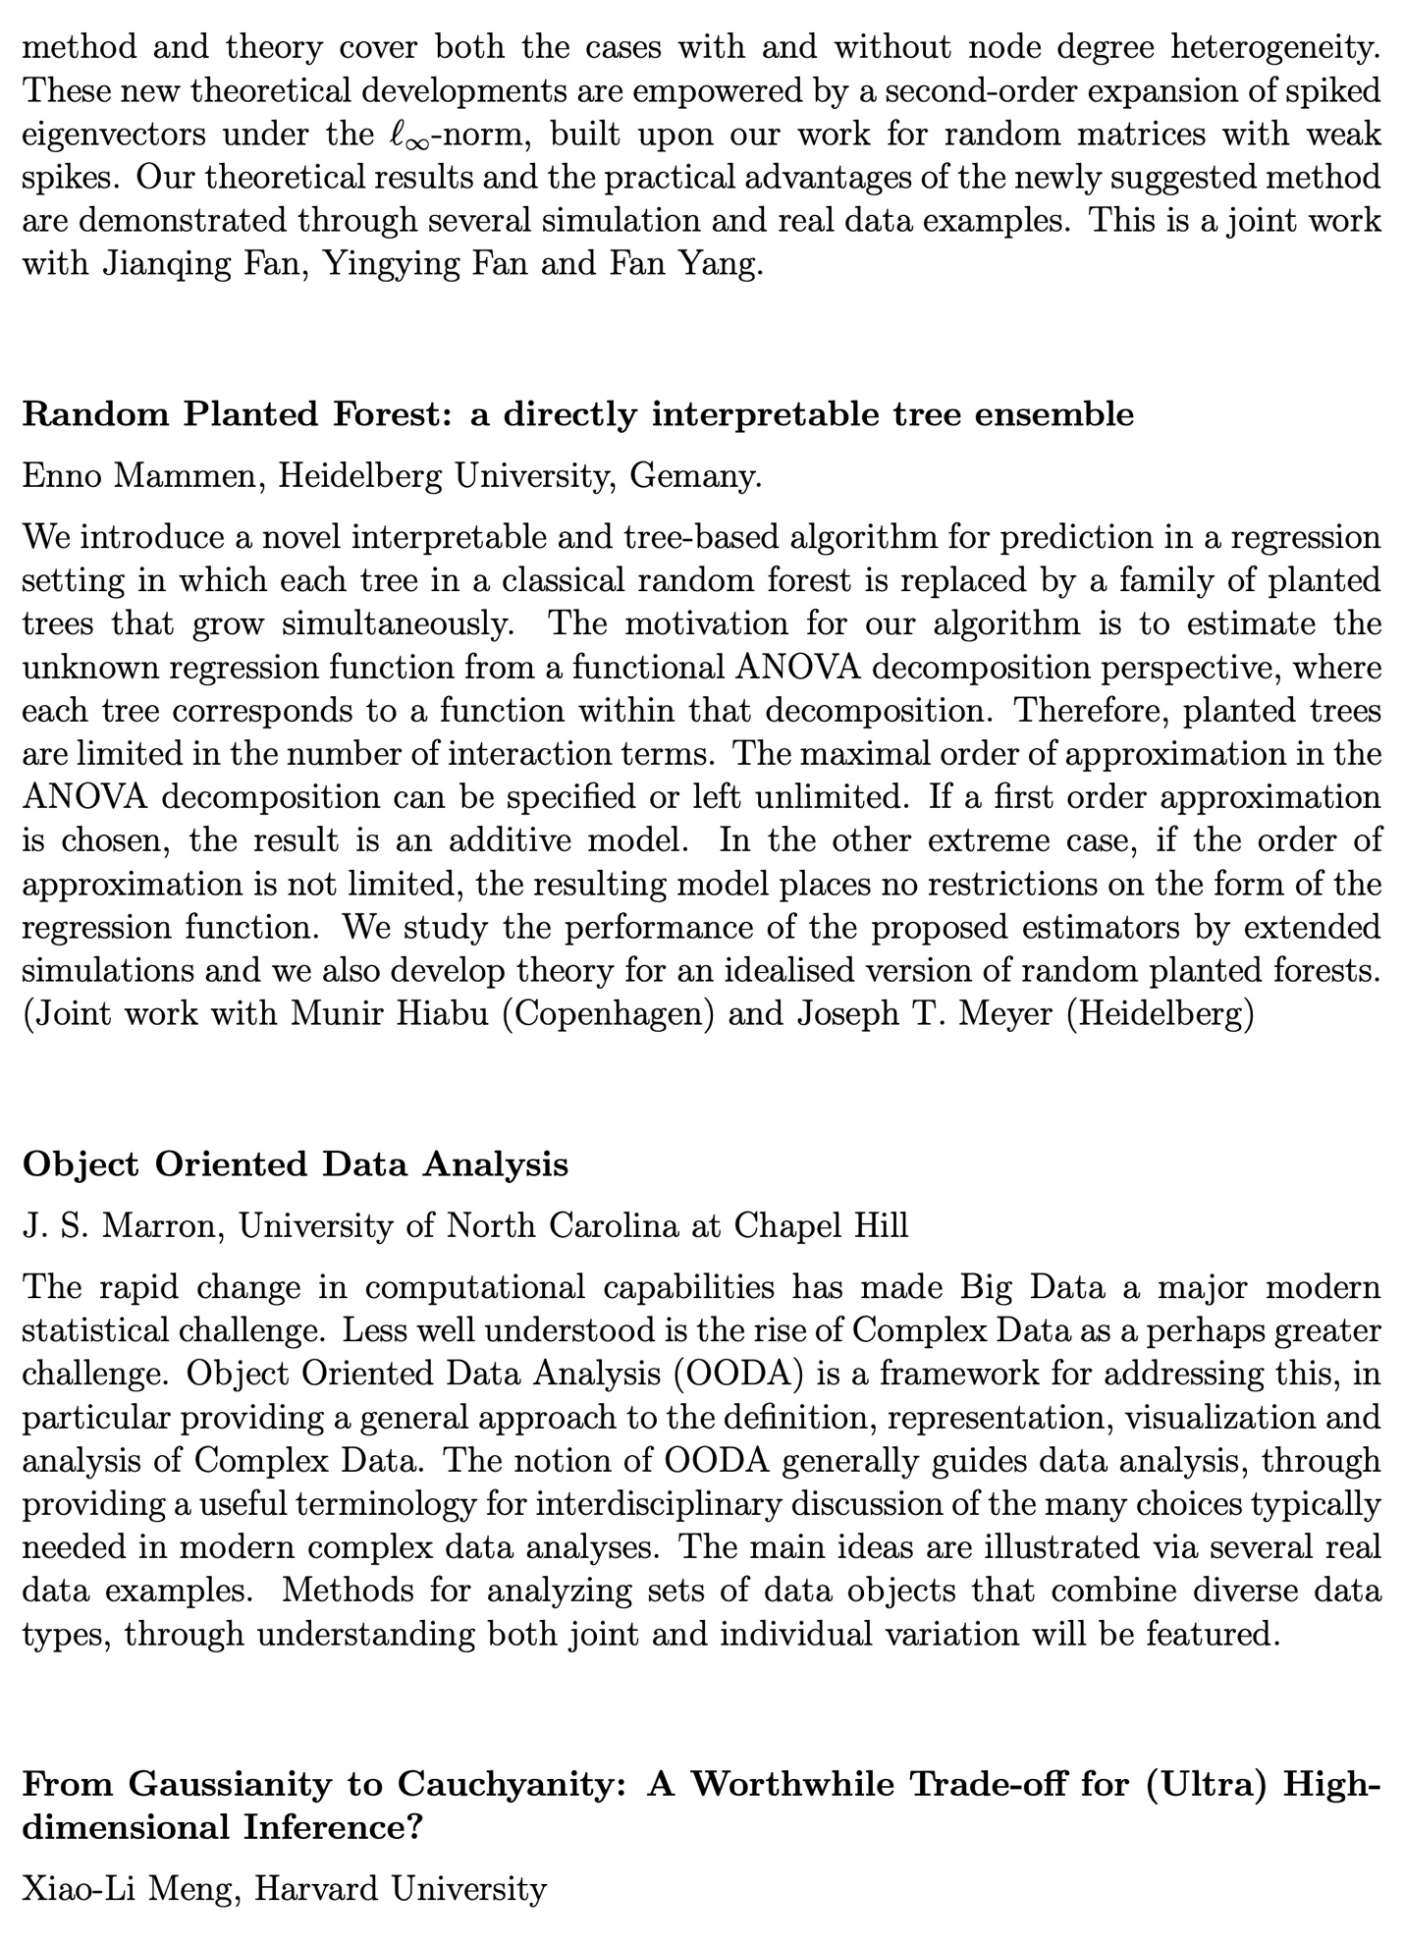

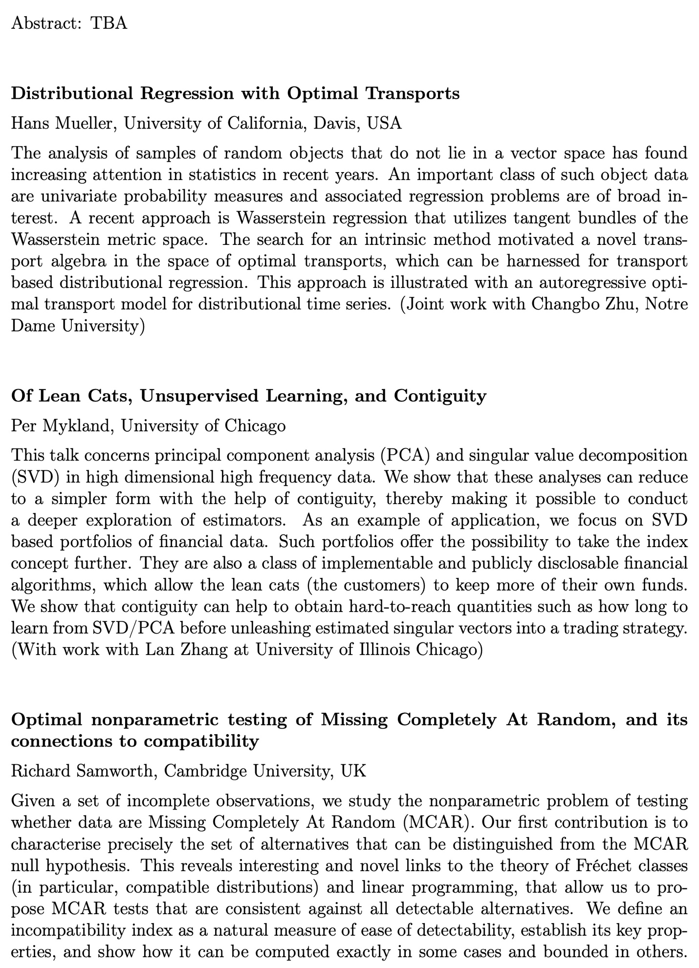

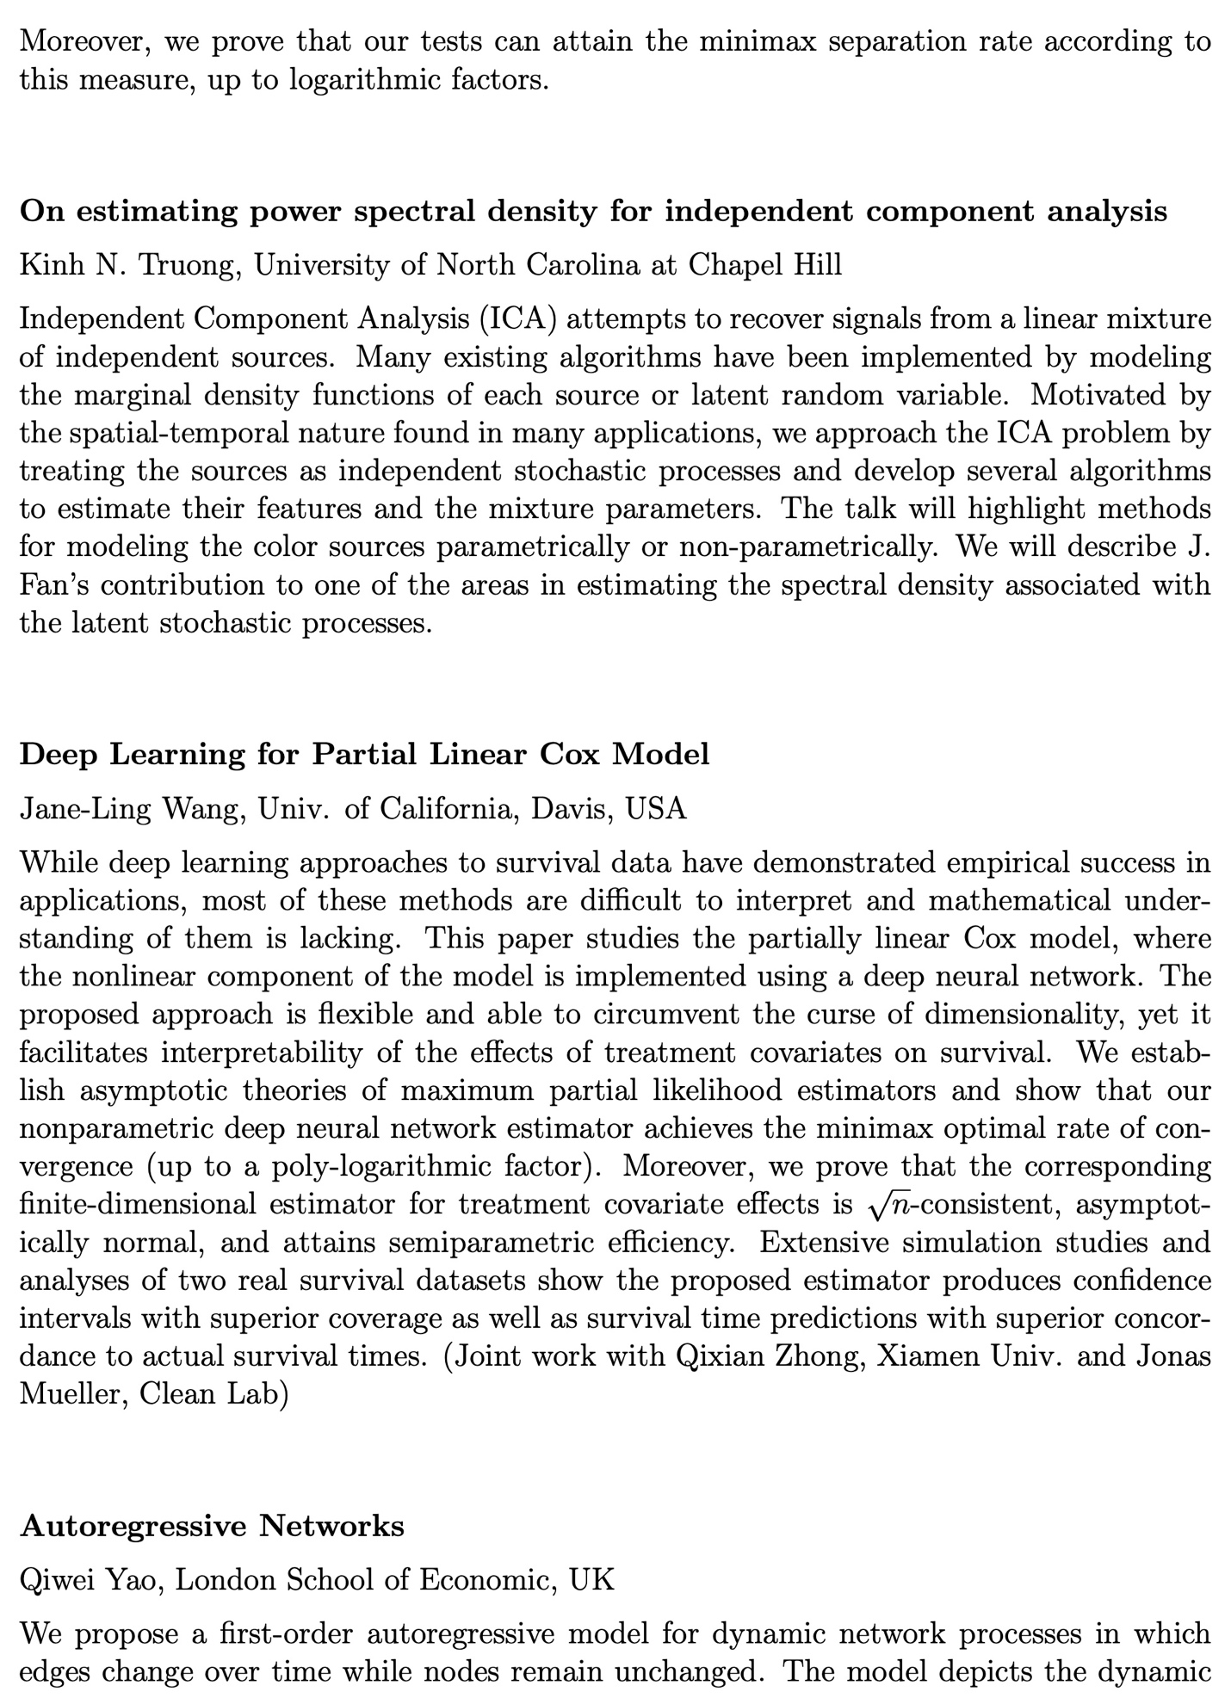

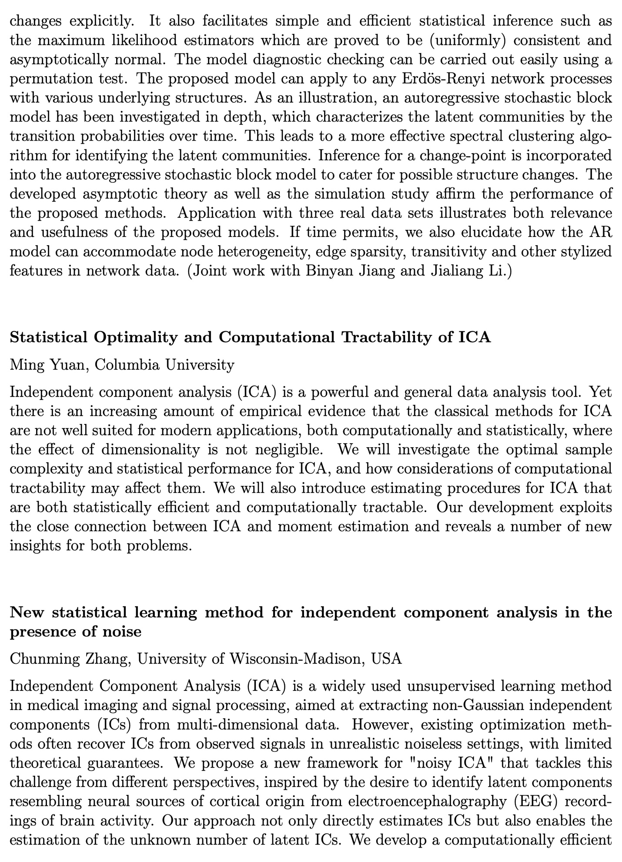

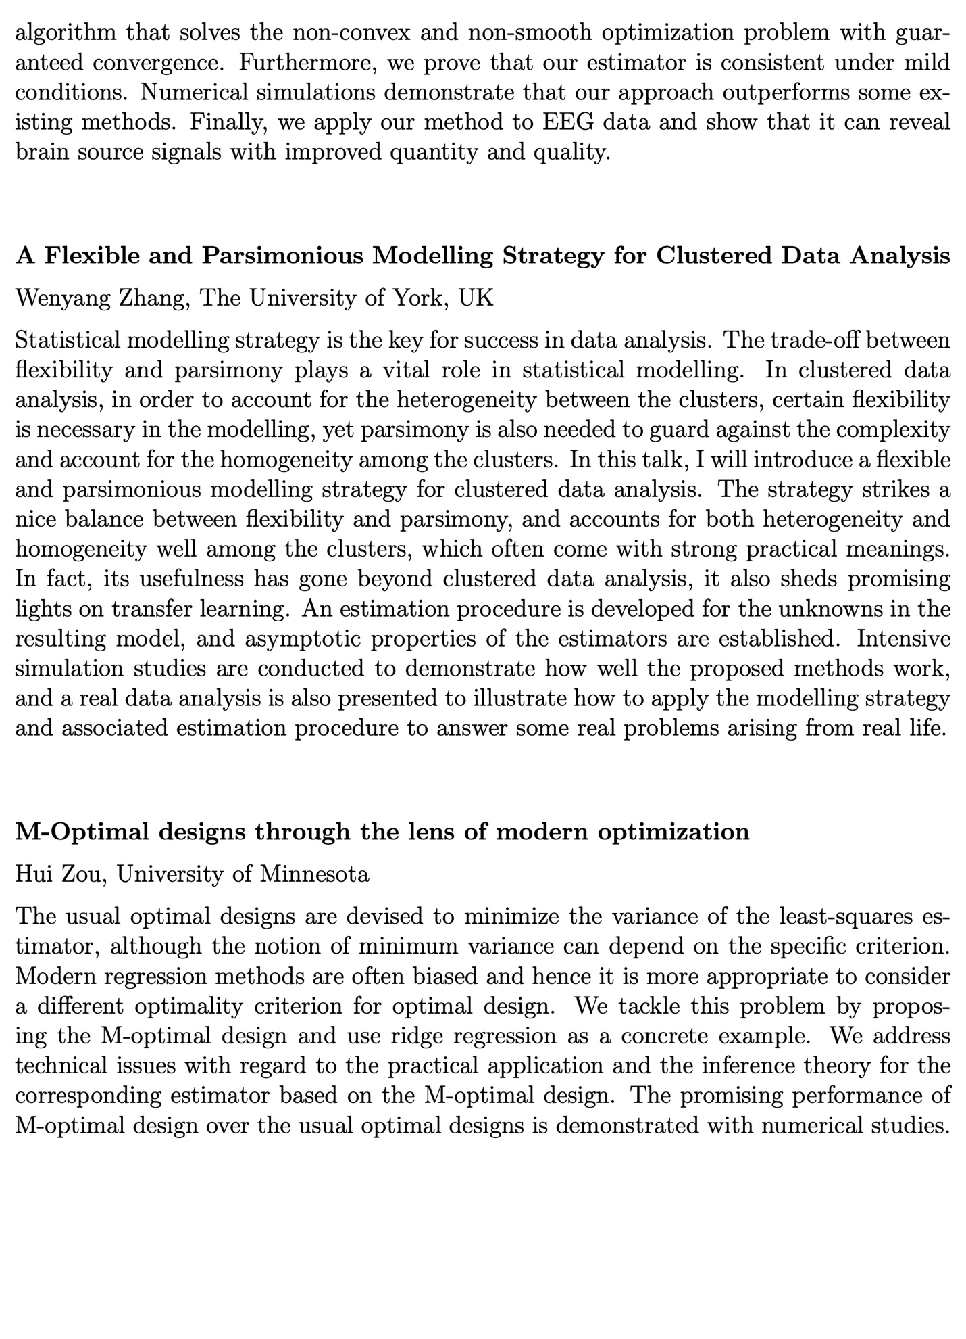

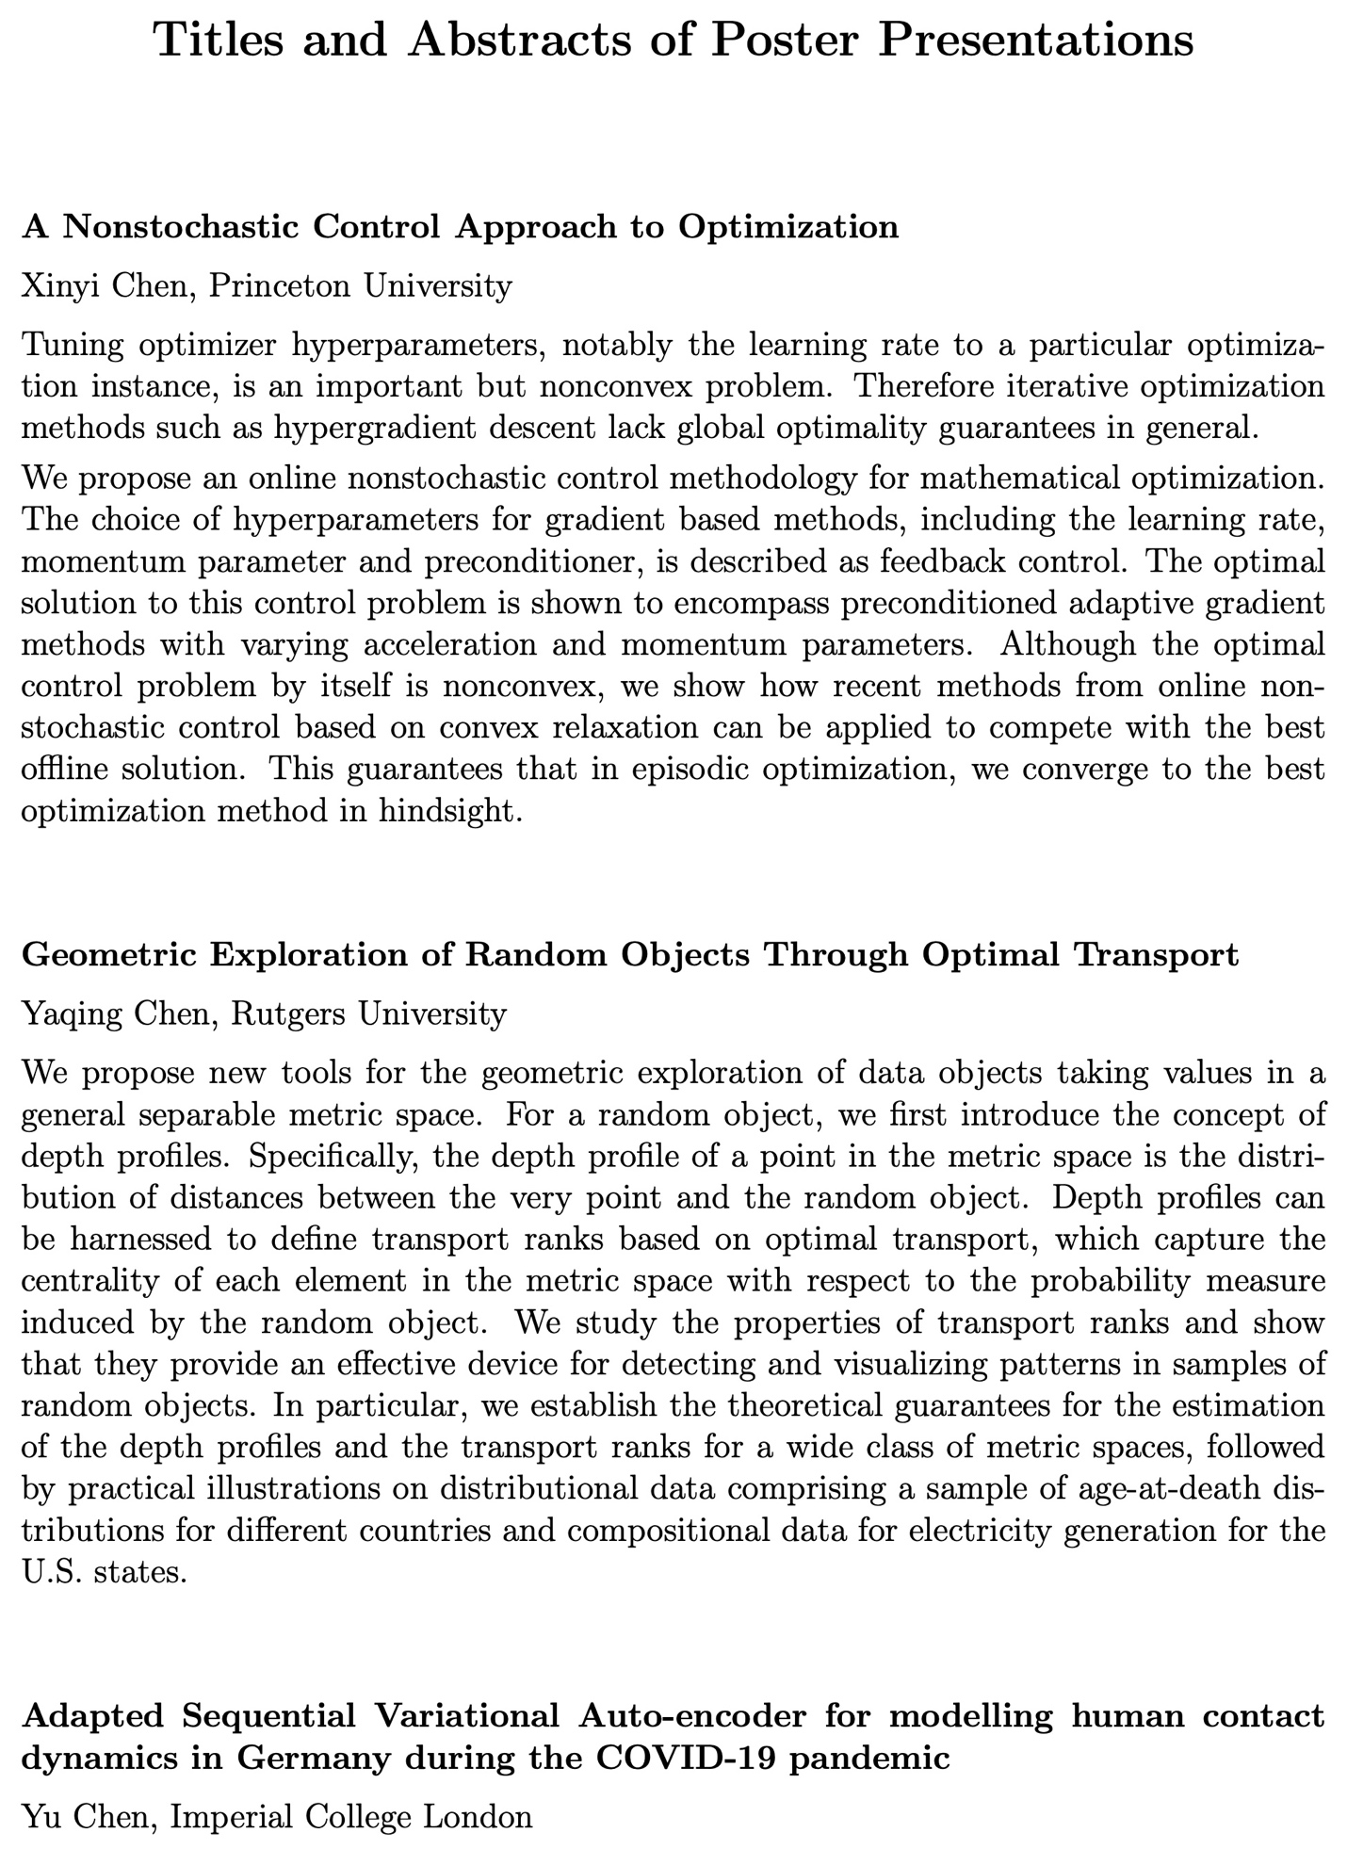

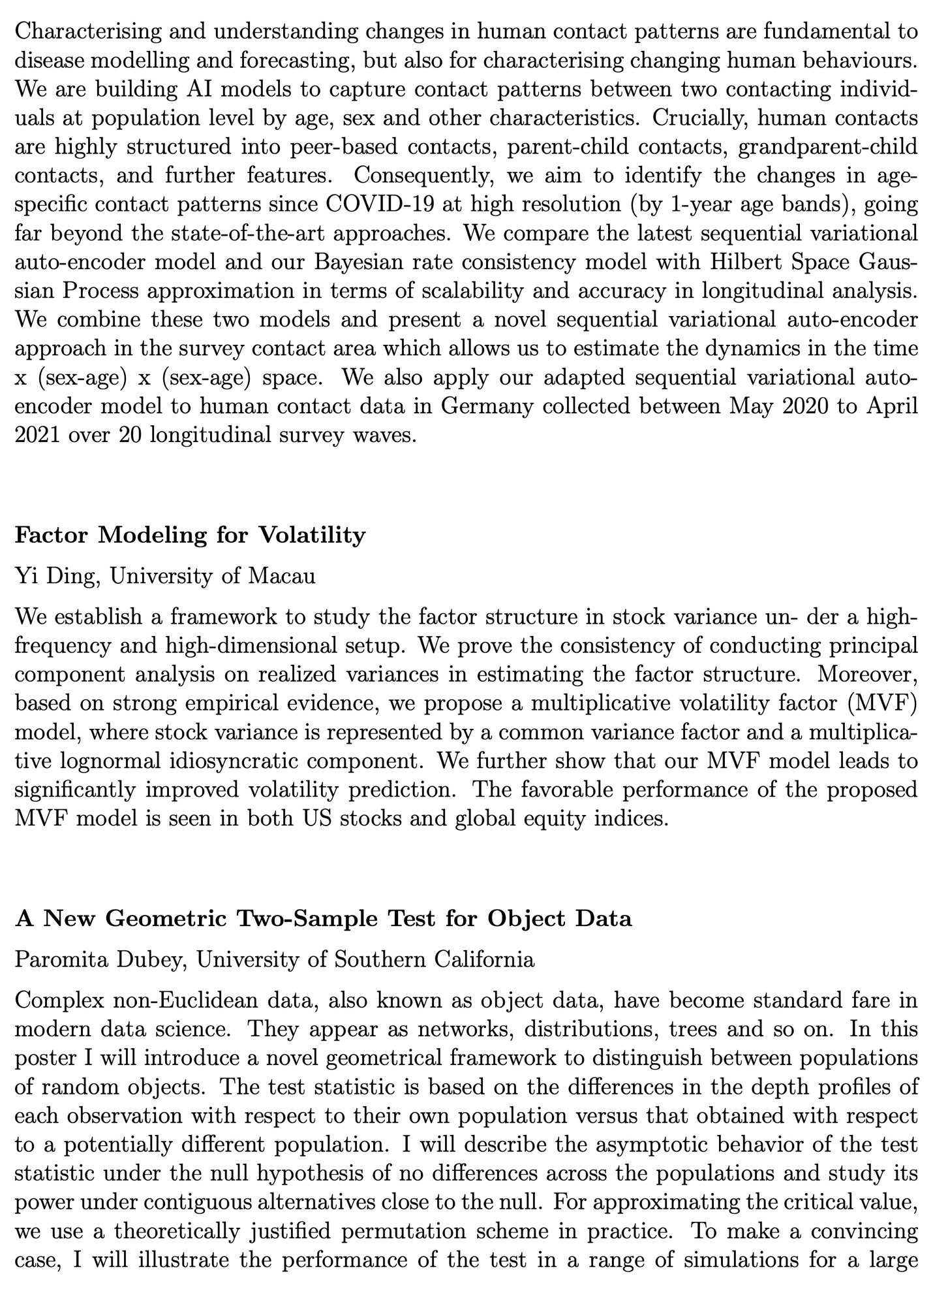

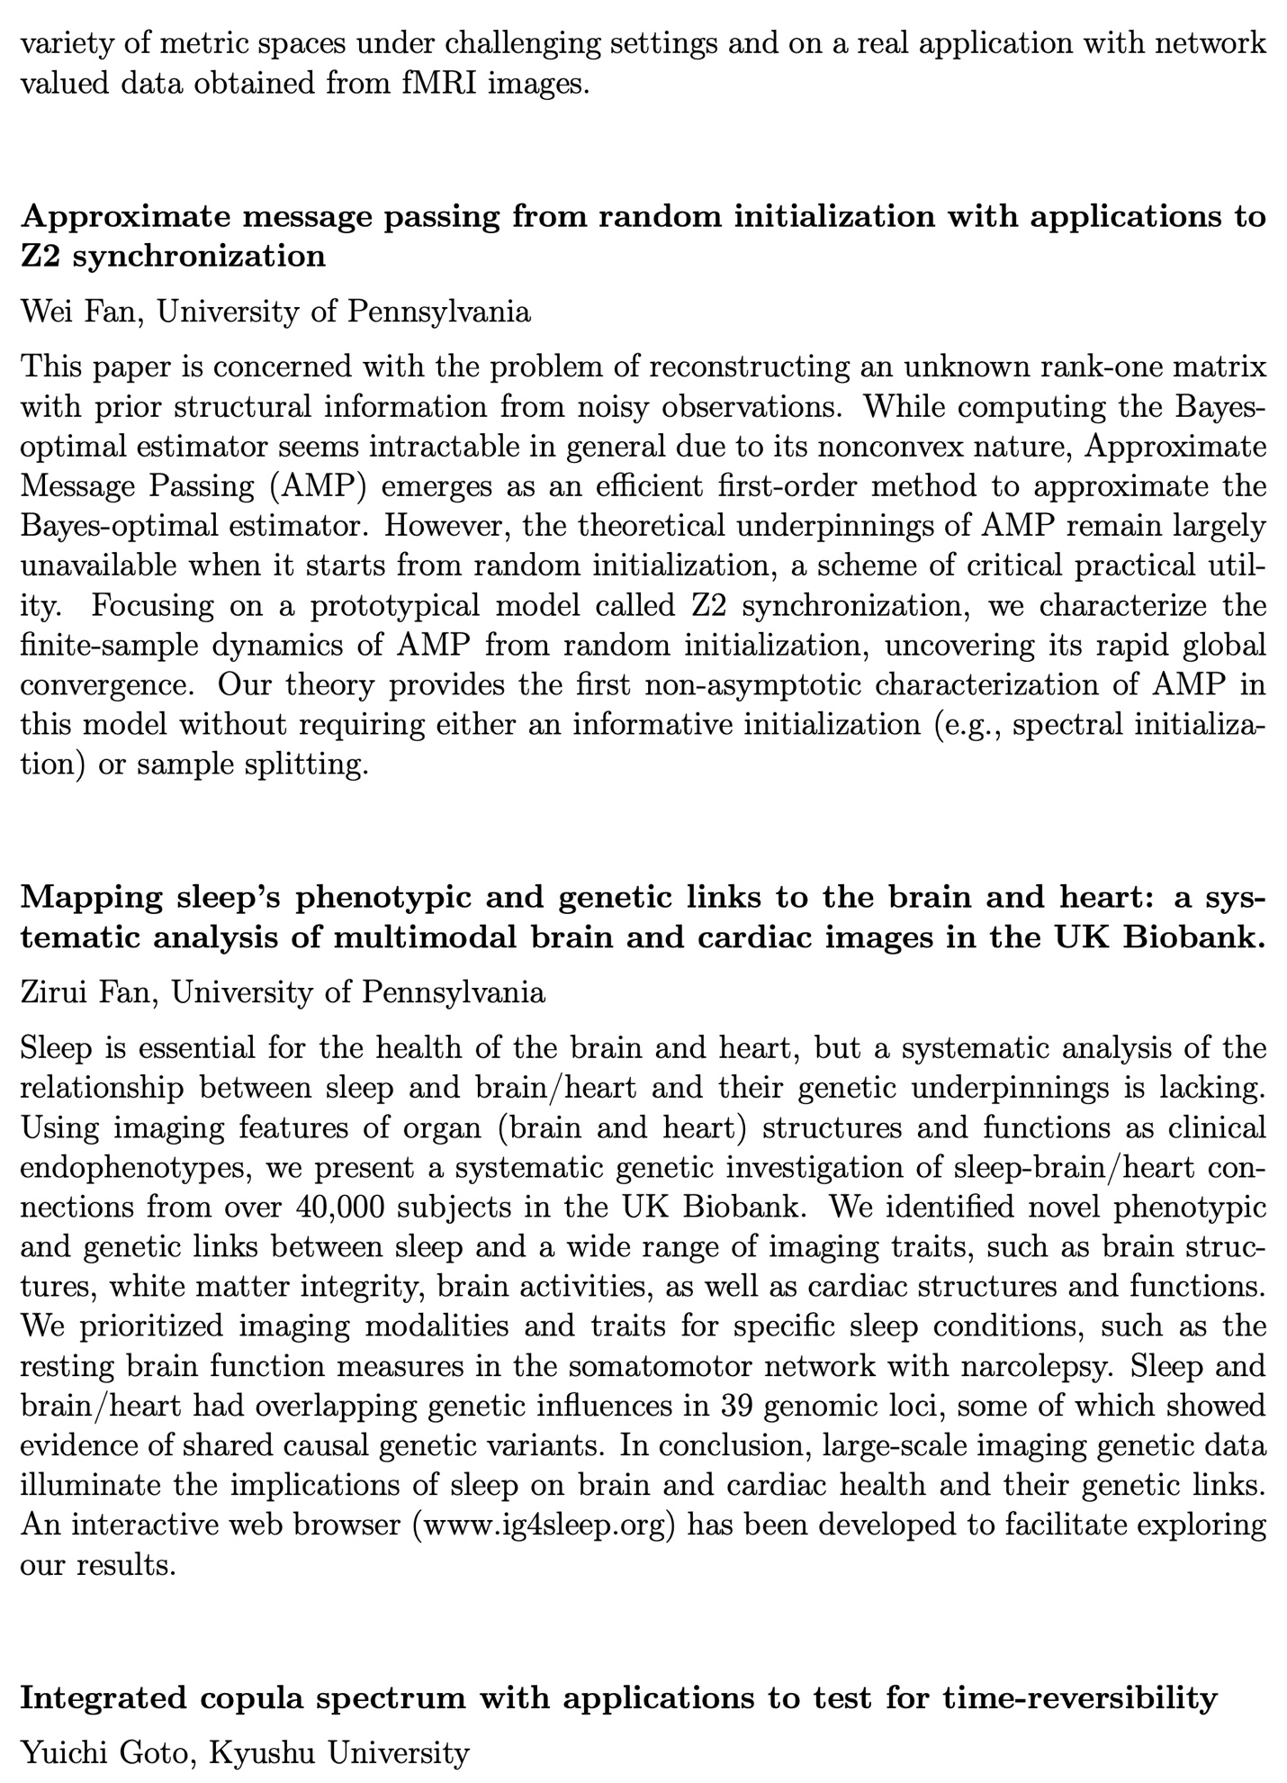

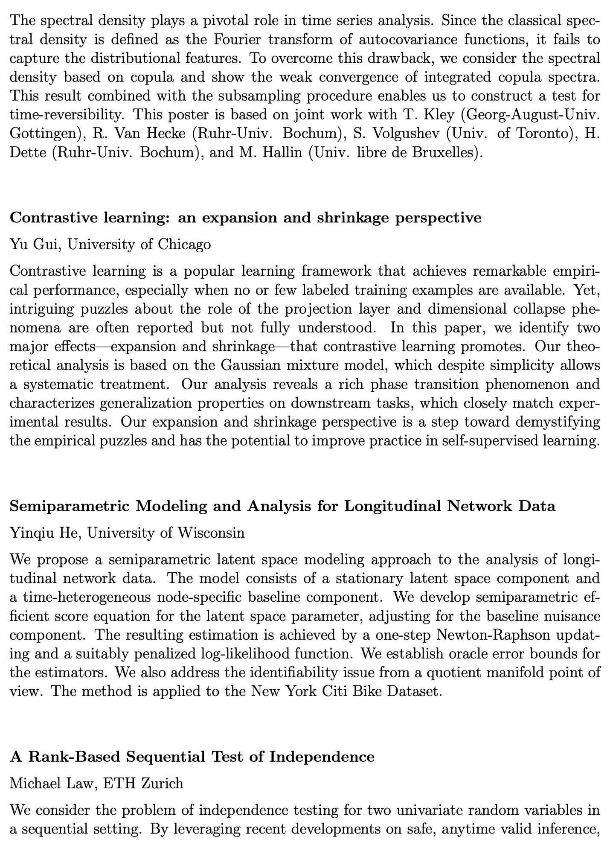

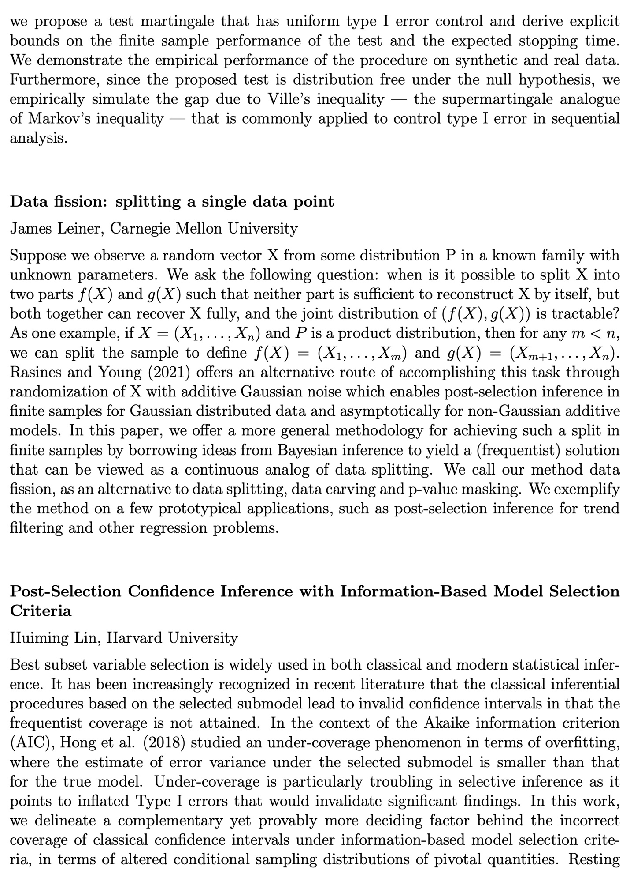

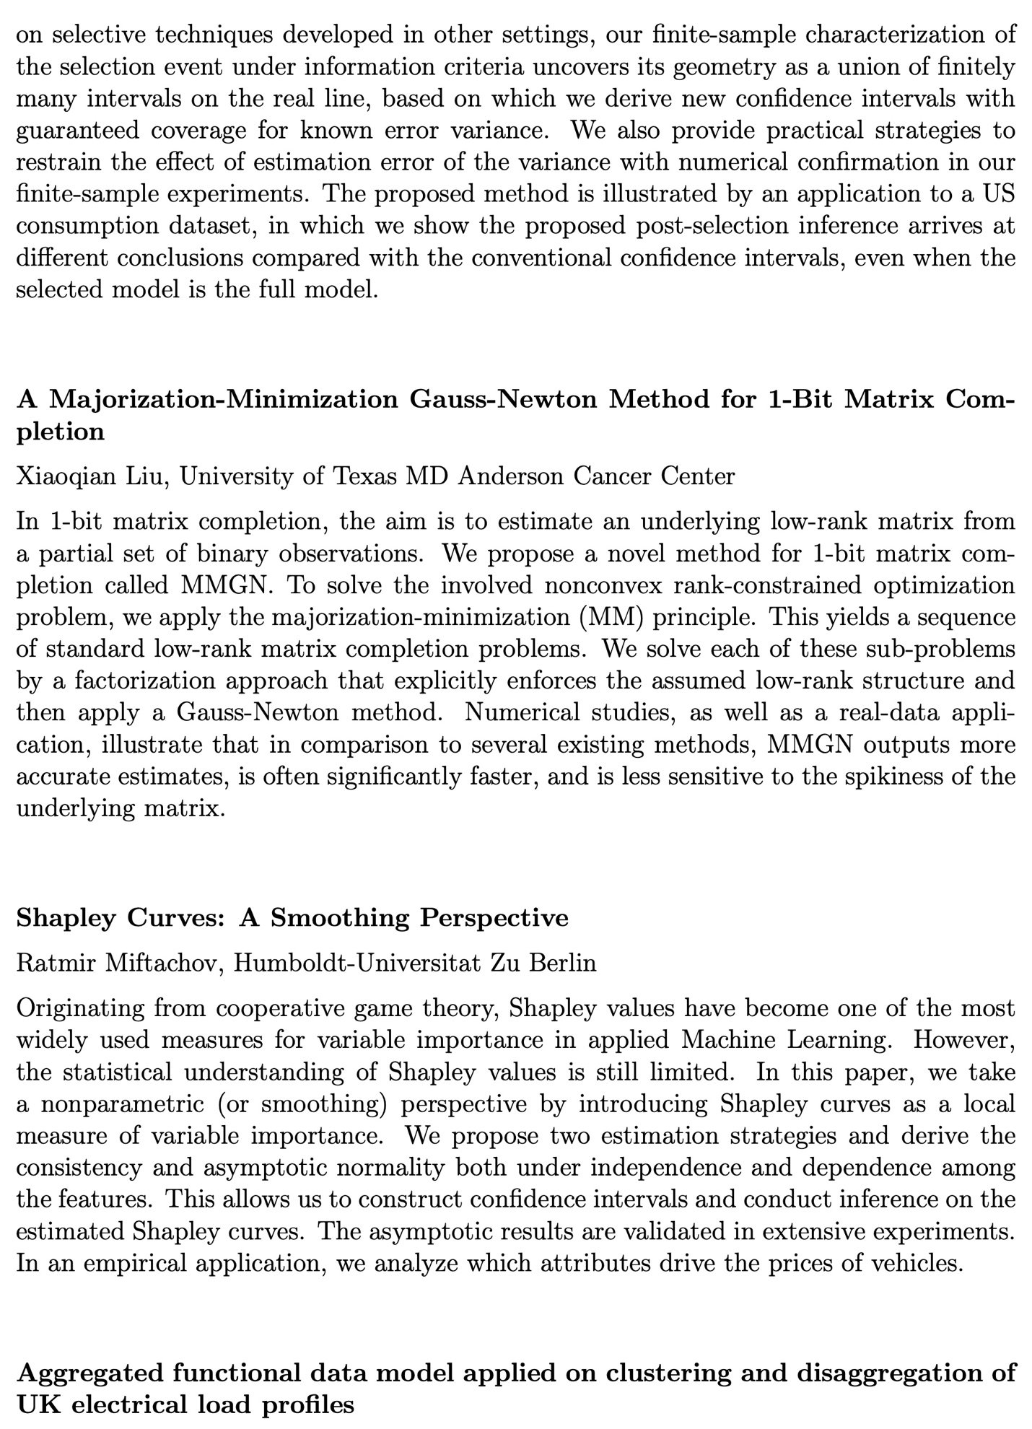

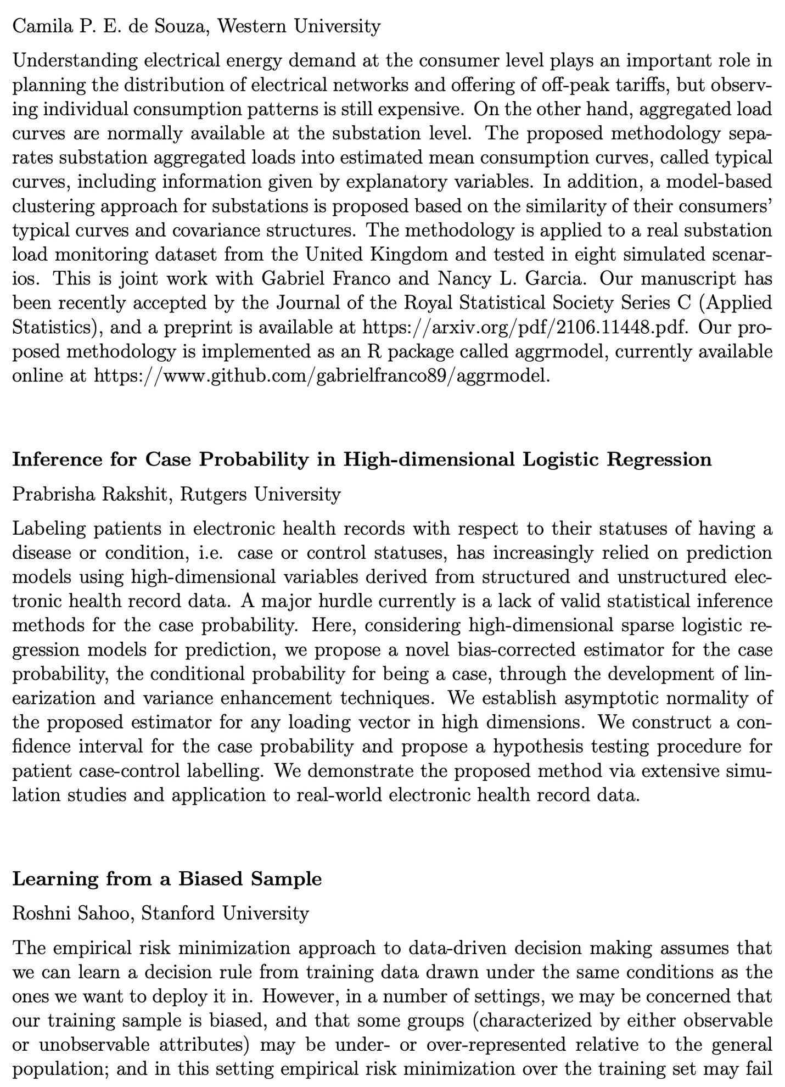

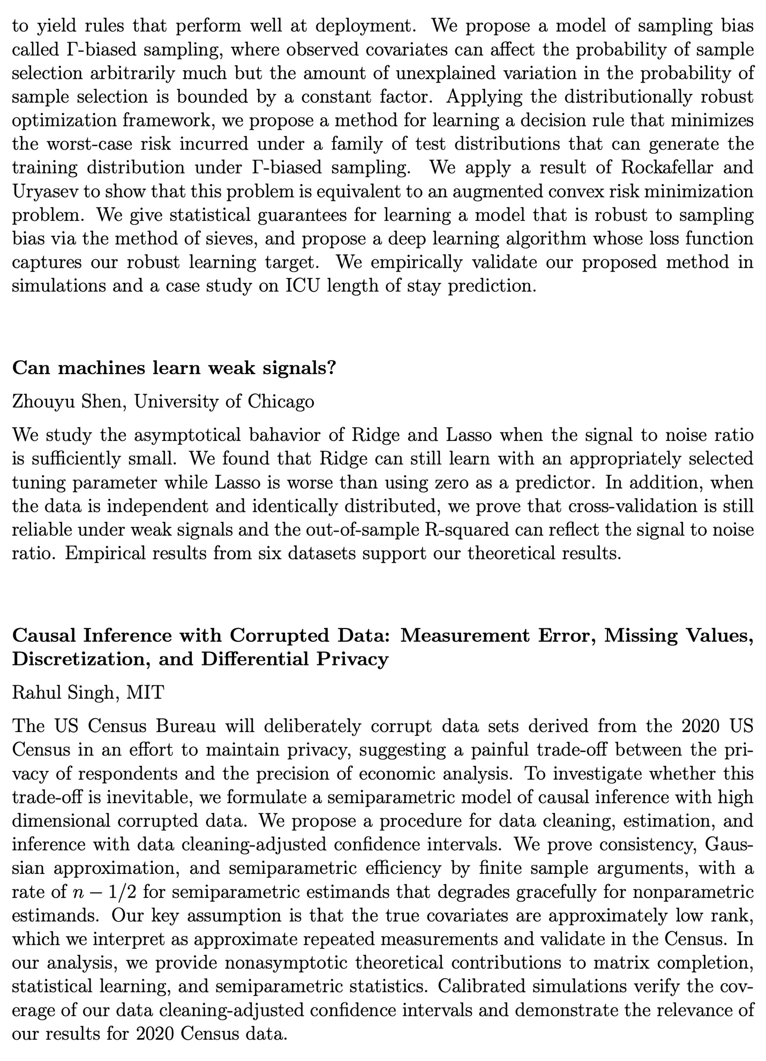

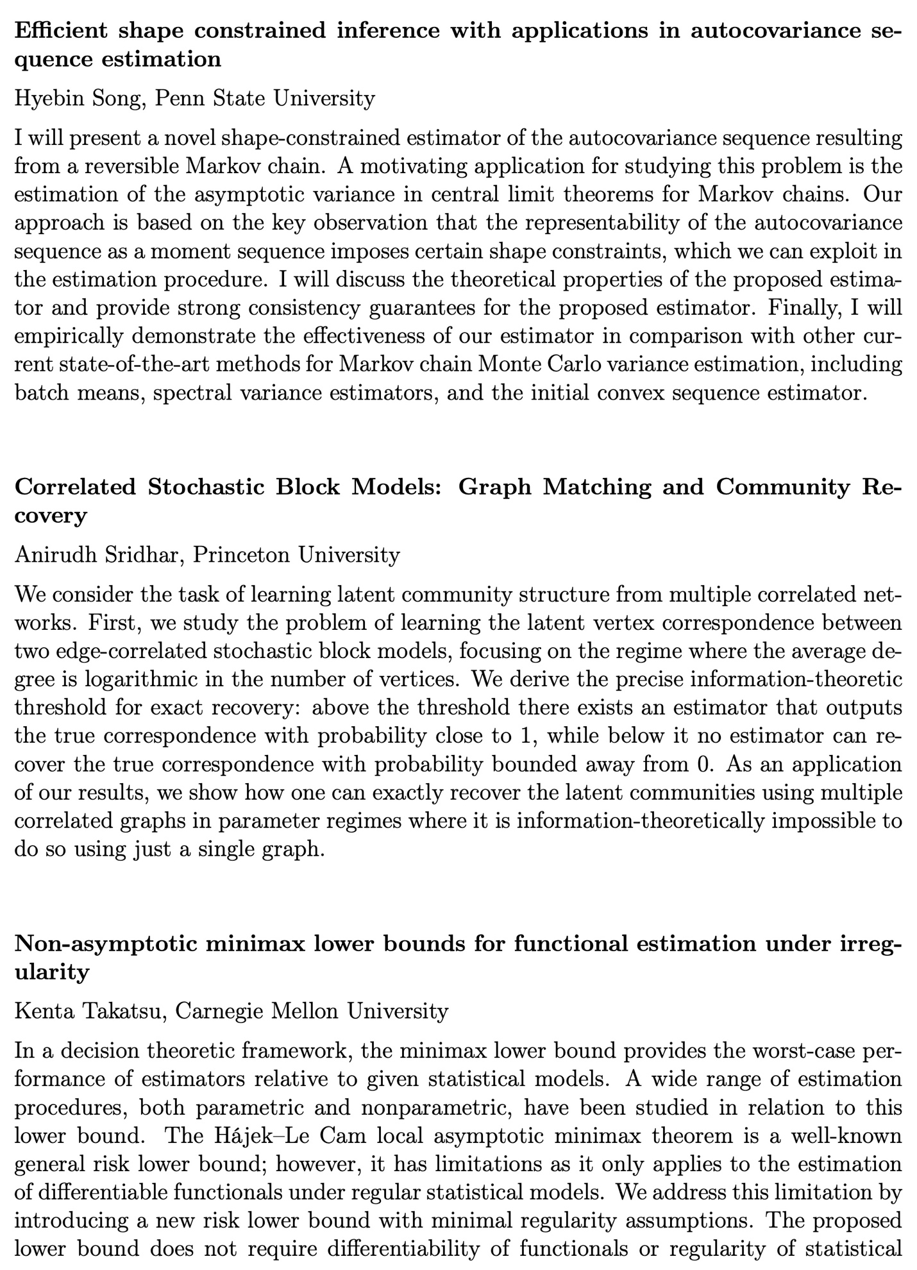

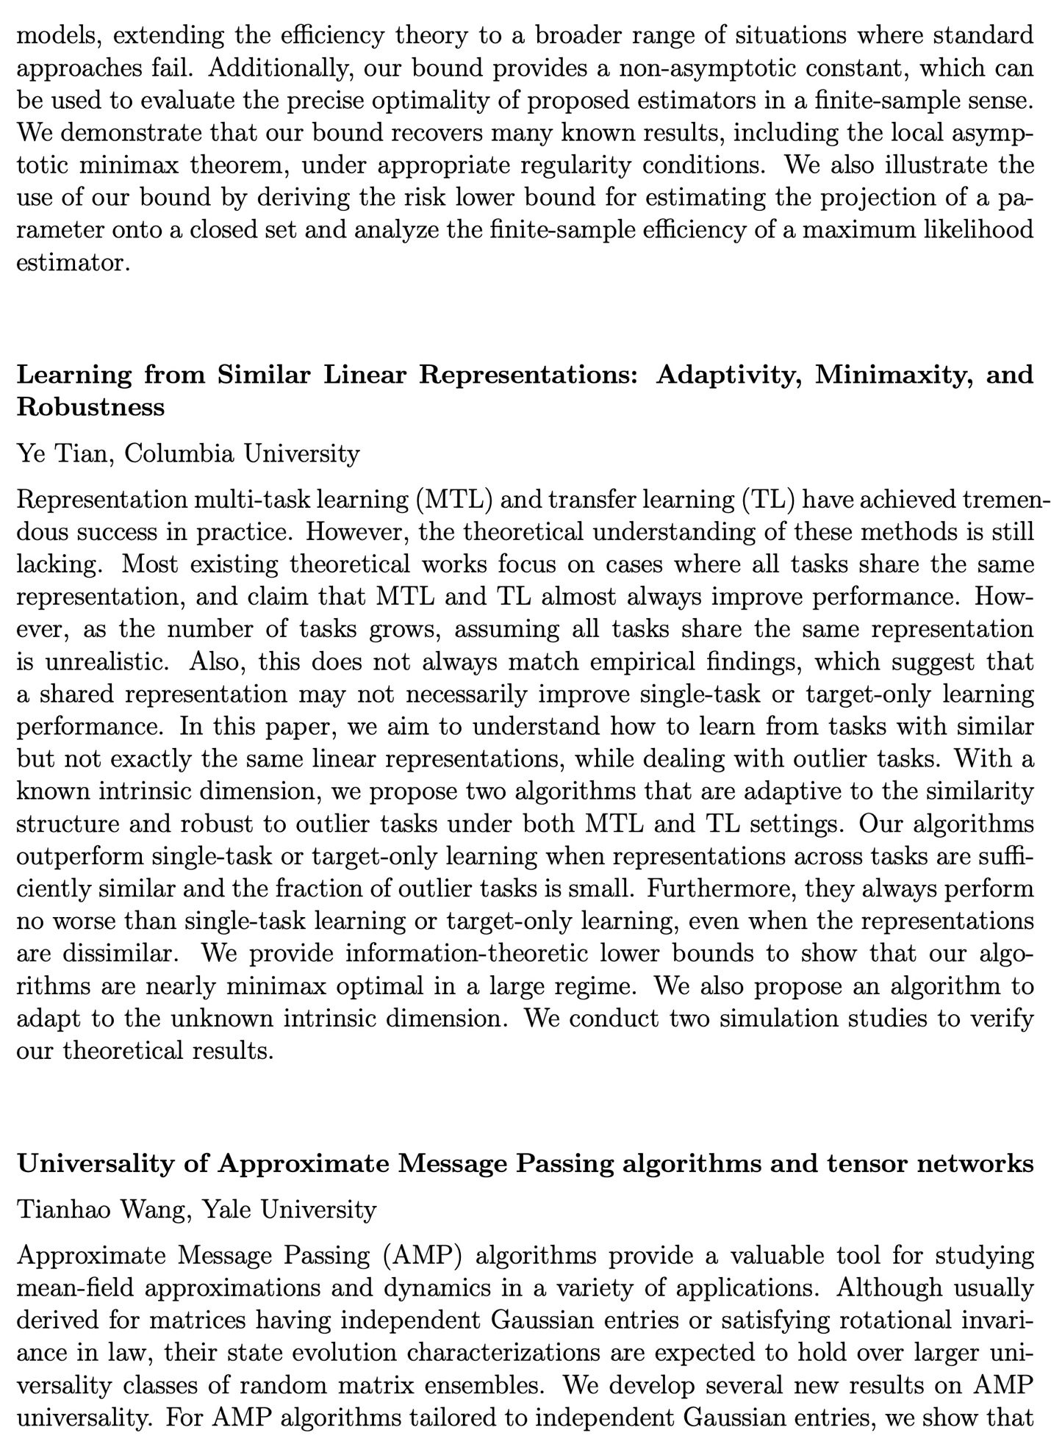

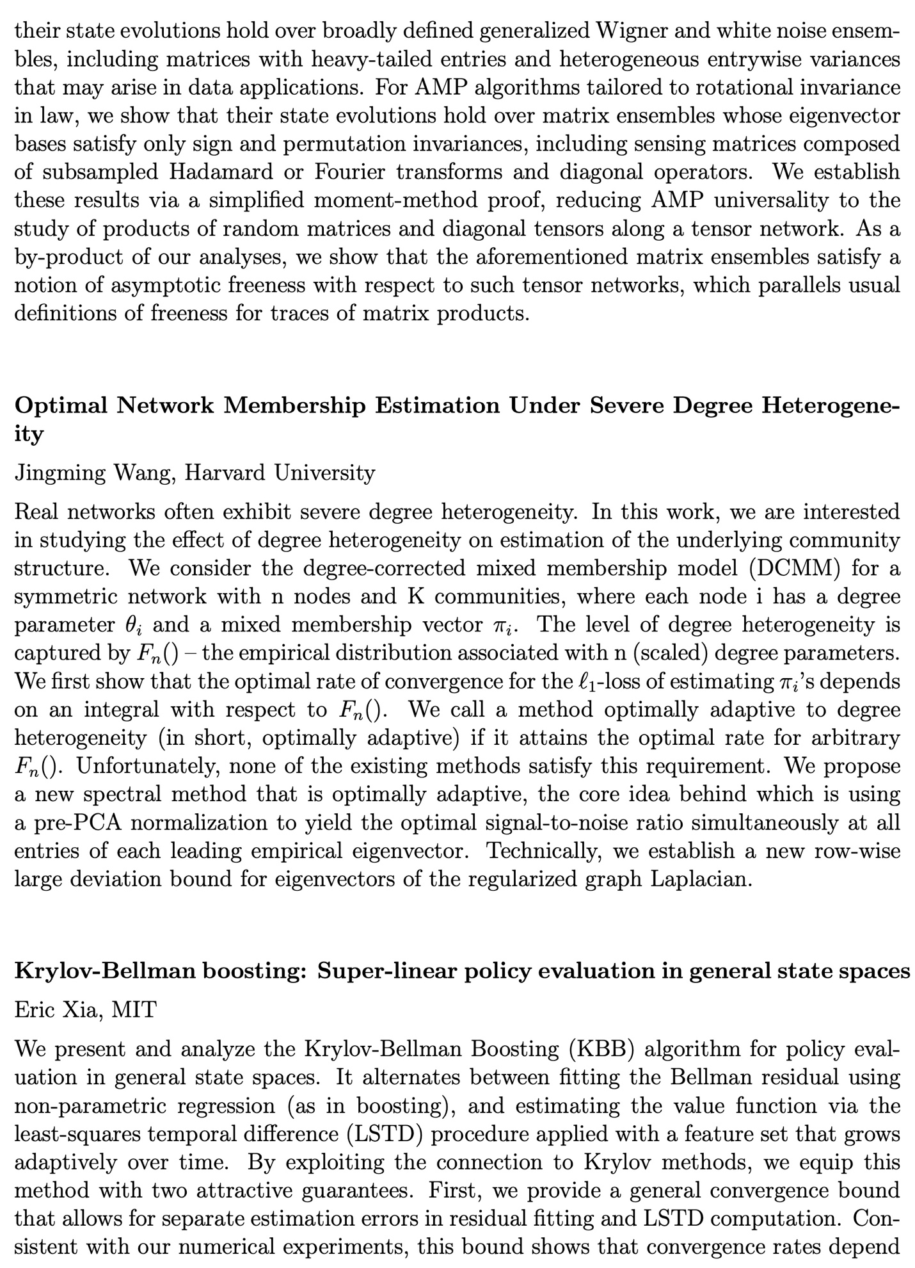

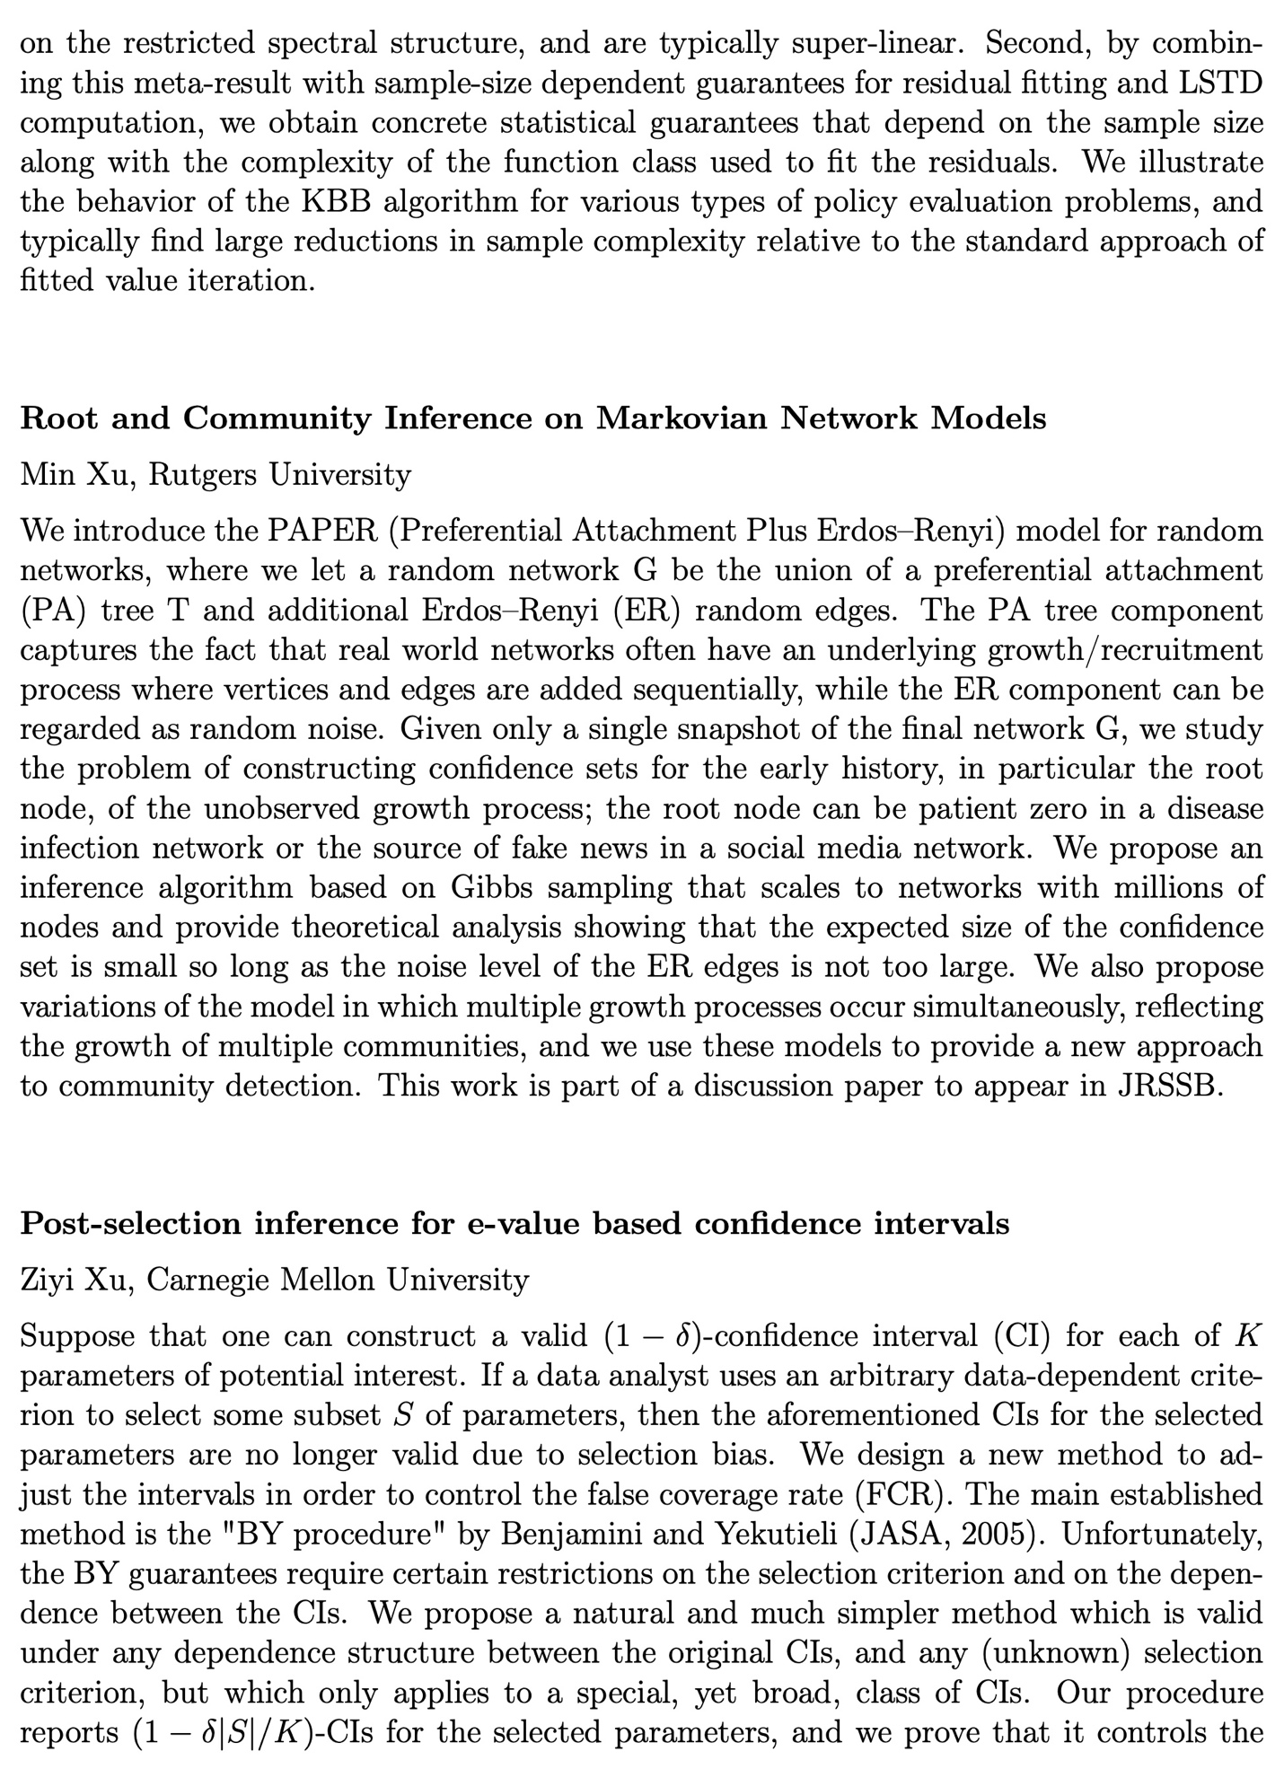

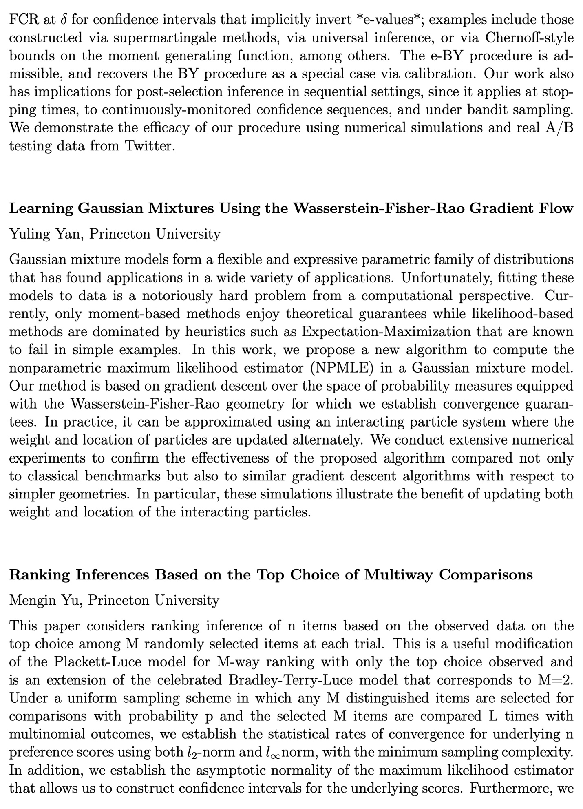

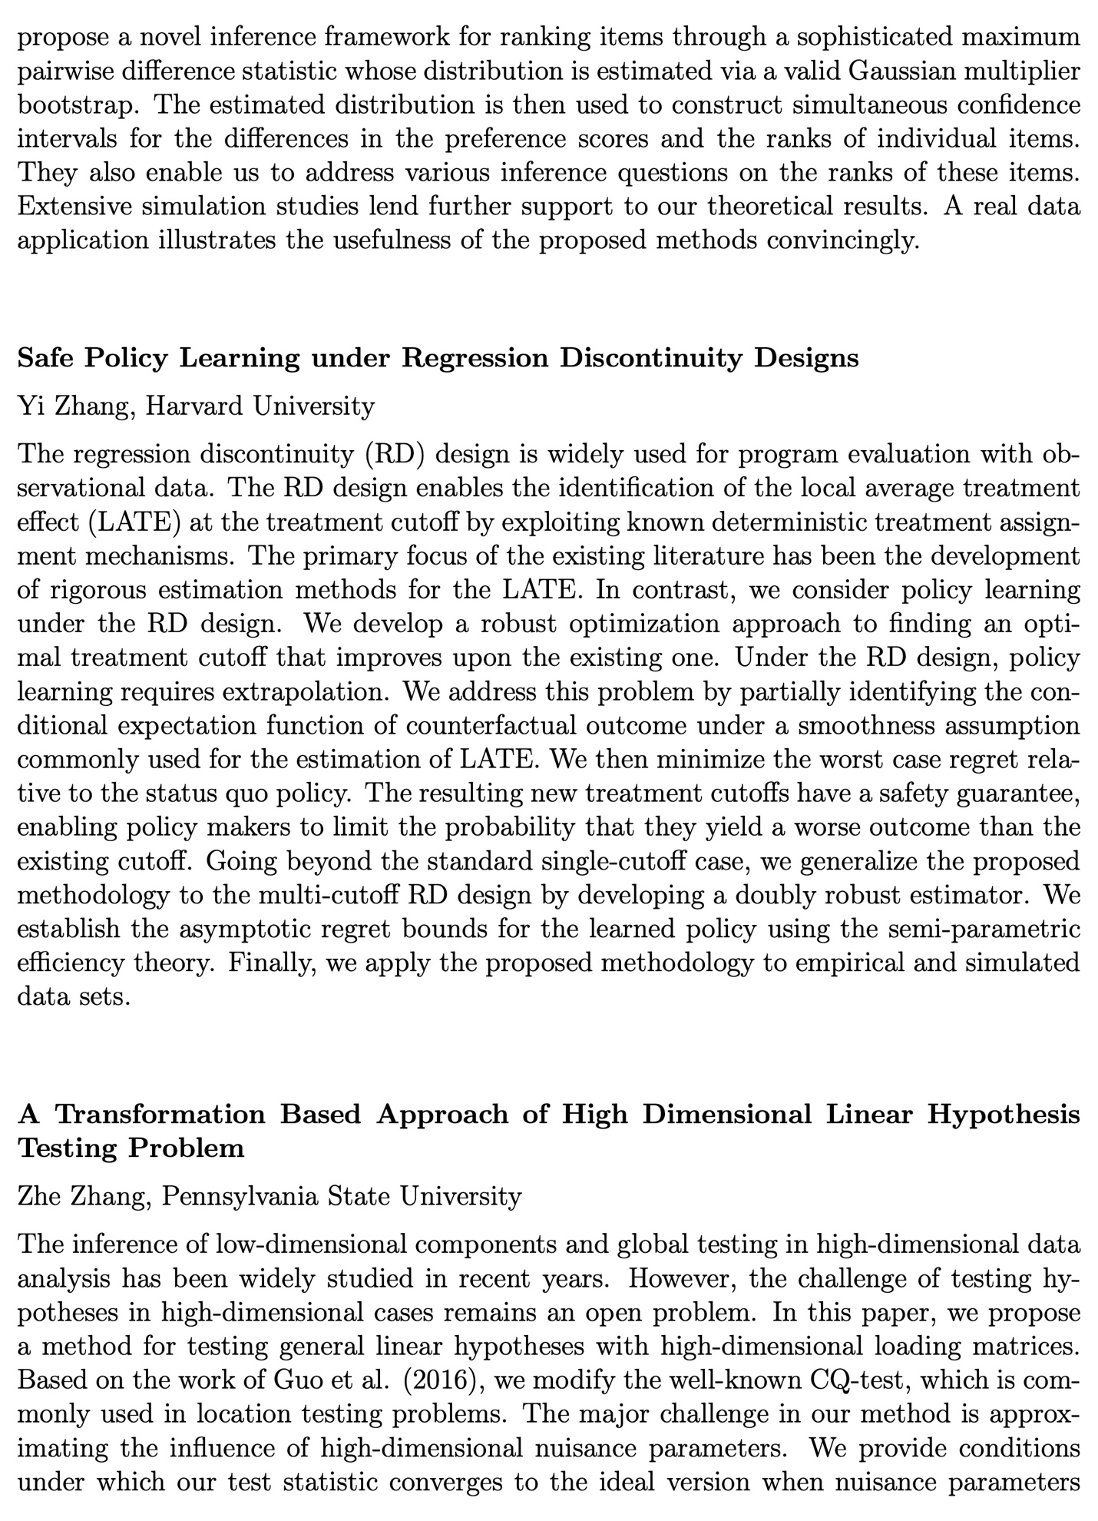

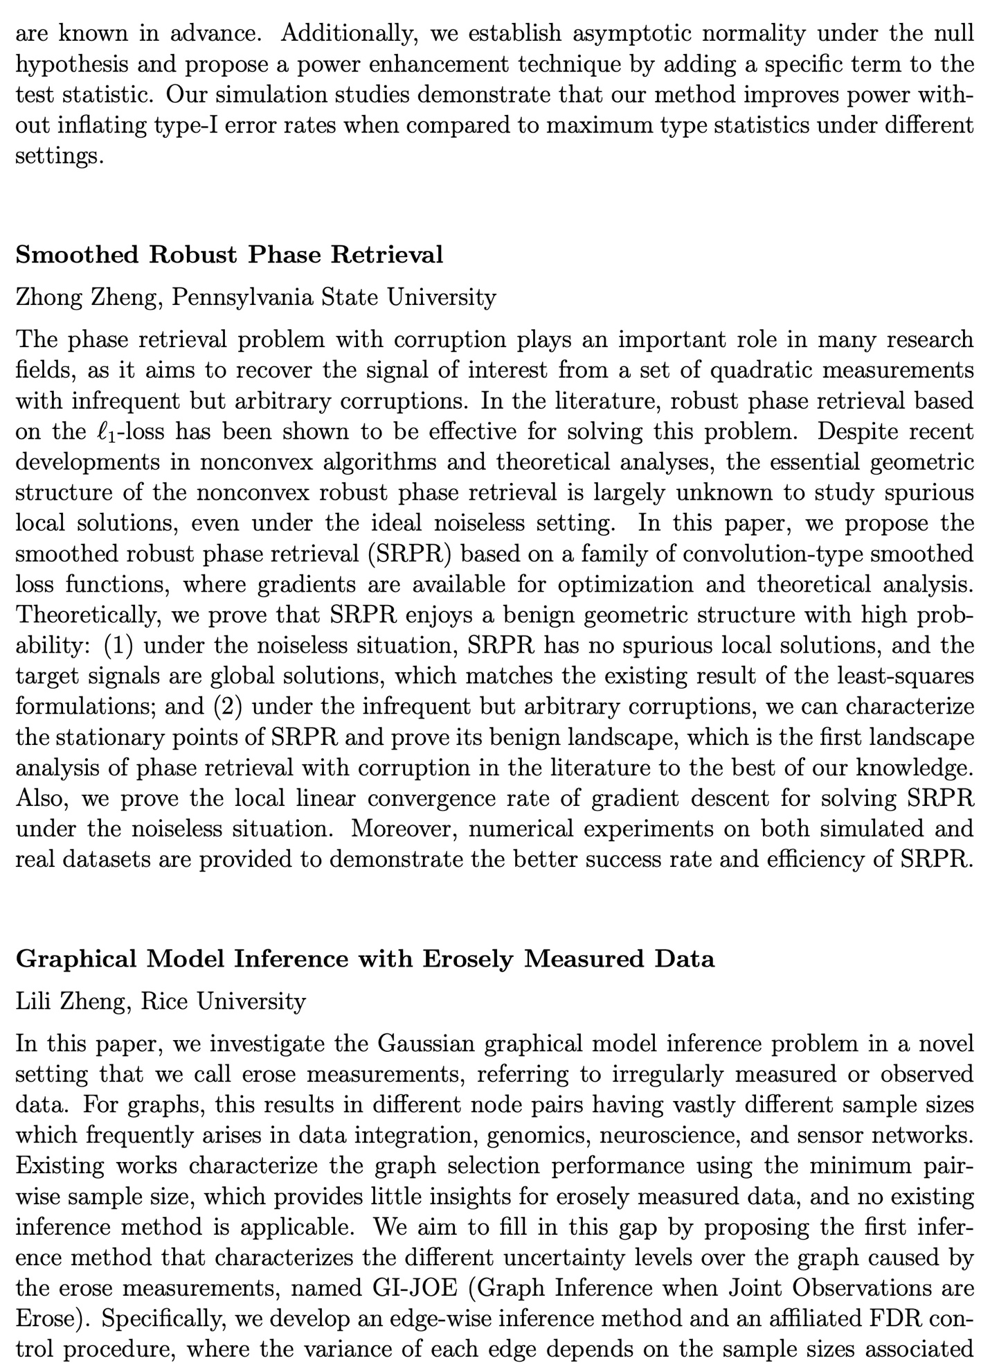

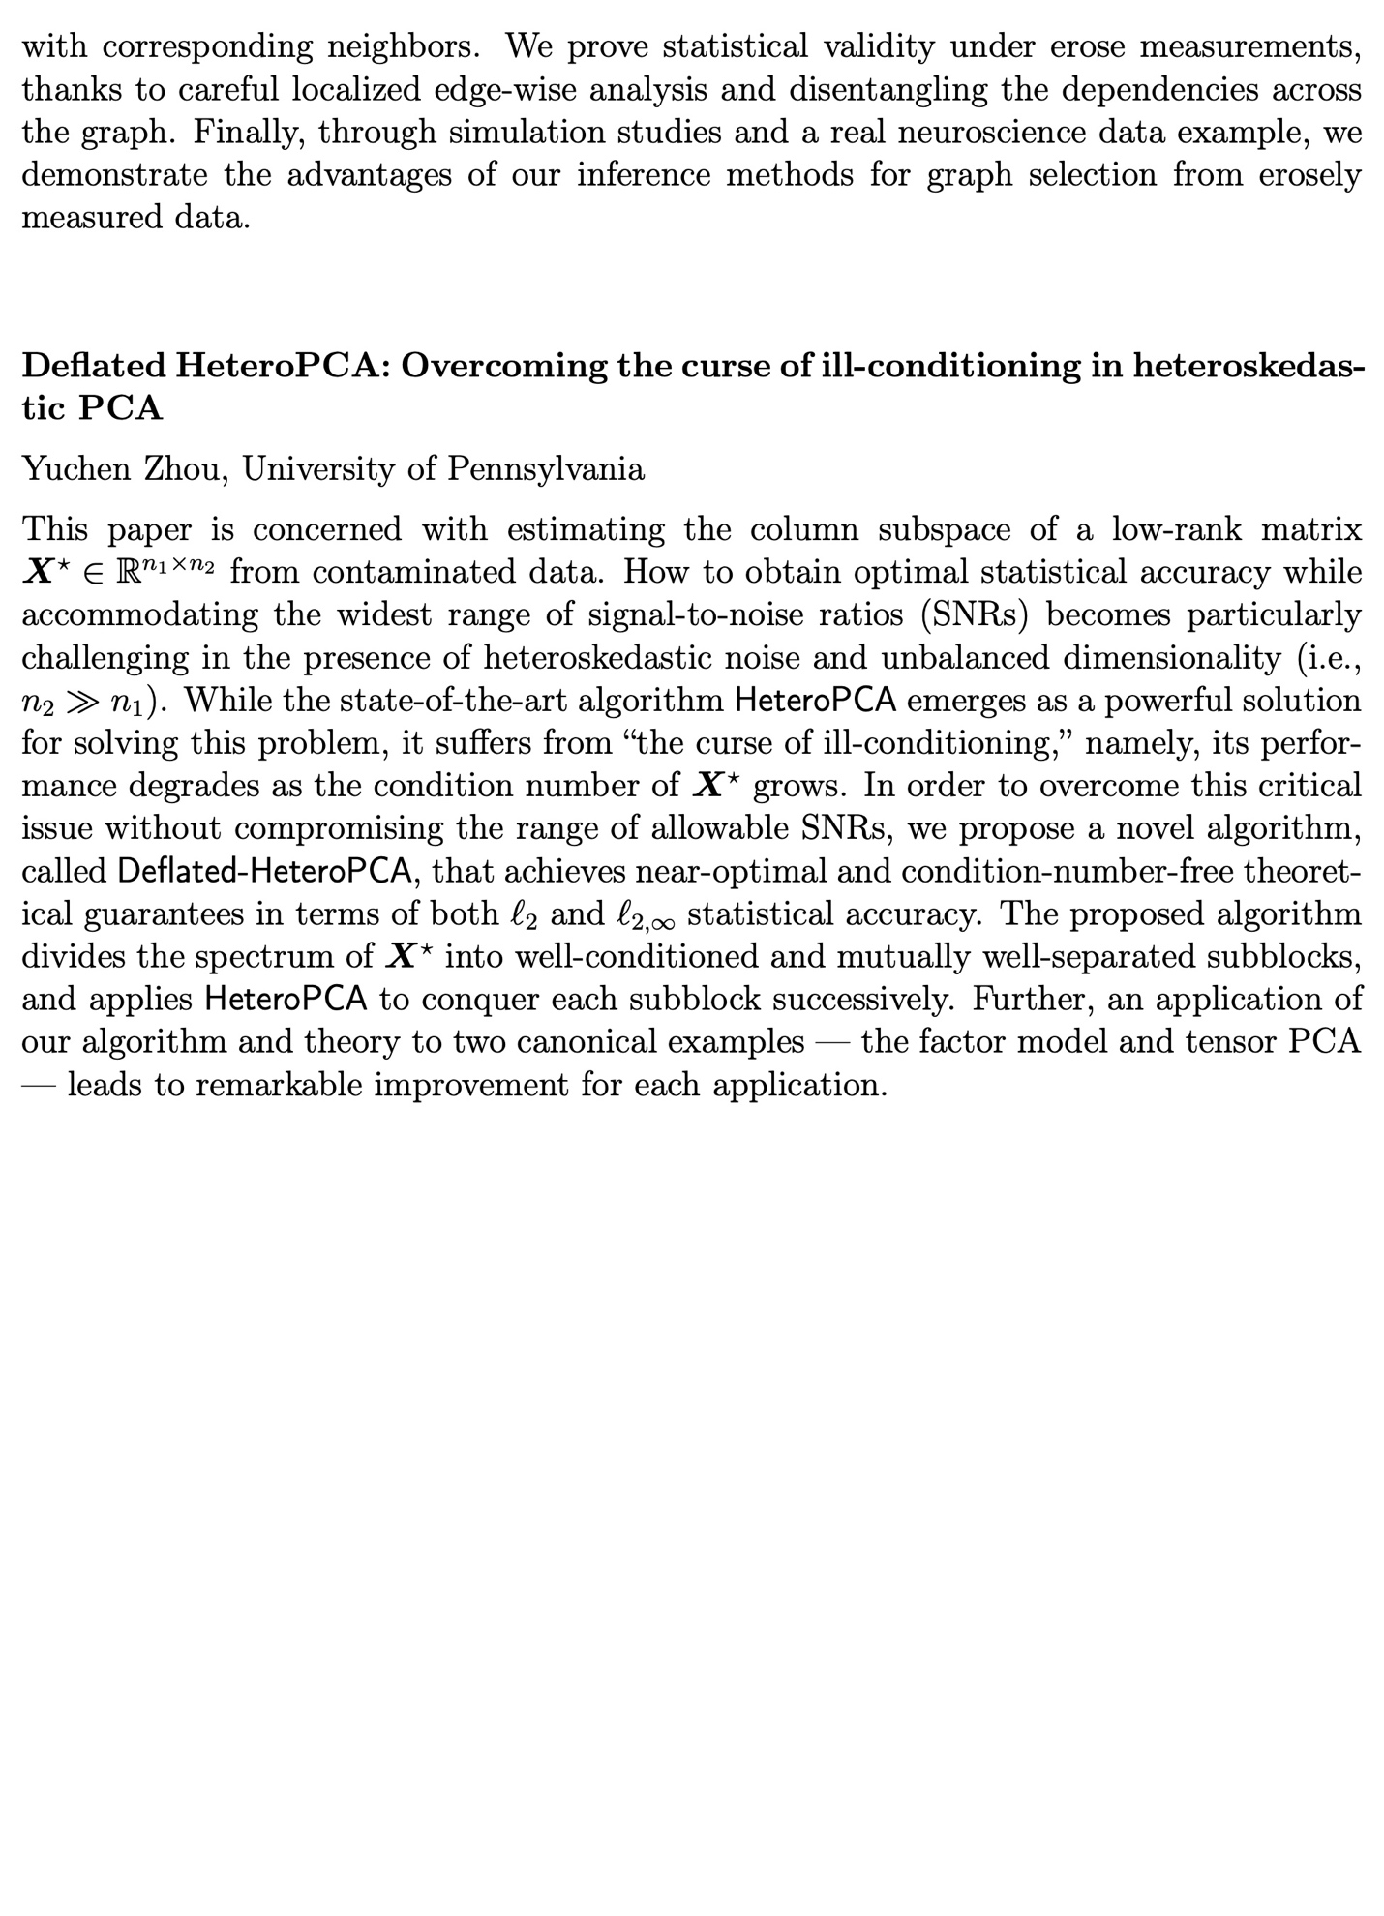

# Invited Speakers & Participants

## **Invited Speakers**

[Yacine Ait-Sahalia](https://fan60.princeton.edu/speakers/yacine-ait-sahalia) (Princeton University)

[Heather Battey](https://fan60.princeton.edu/speakers/heather-battey) (Imperial College of London)

[Peter Bickel](https://fan60.princeton.edu/speakers/peter-bickel) (UC at Berkeley)

[Peter Bühlmann](https://fan60.princeton.edu/speakers/peter-b%C3%BChlmann) (ETH Zürich)

[Jianwen Cai](https://fan60.princeton.edu/speakers/jianwen-cai) (UNC at Chapel Hill)

[Tony Cai](https://fan60.princeton.edu/speakers/tony-cai) (UPenn)

[Ming-Yen Cheng](https://fan60.princeton.edu/speakers/ming-yen-cheng) (Hong Kong Baptist University)

[David Donoho](https://fan60.princeton.edu/speakers/david-donoho) (Stanford)

[Philip A. Ernst](https://fan60.princeton.edu/speakers/philip-ernst) (Imperial College London)

[Irène Gijbels](https://fan60.princeton.edu/speakers/ir%C3%A8ne-gijbels) (KU Leuven in Belgium)

[Marc Hallin](https://fan60.princeton.edu/speakers/marc-hallin) (Université libre de Bruxelles)

[Wolfgang Härdle](https://fan60.princeton.edu/speakers/wolfgang-h%C3%A4rdle) (Humboldt-Universität zu Berlin)

[Kosuke Imai](https://fan60.princeton.edu/speakers/kosuke-imai) (Harvard)

[Jiashun Jin](https://fan60.princeton.edu/speakers/jiashun-jin) (CMU)

[Xihong Lin](https://fan60.princeton.edu/speakers/xihong-lin) (Harvard)

[Jinchi Lv](https://fan60.princeton.edu/speakers/jinchi-lv) (USC)

[Enno Mammen](https://fan60.princeton.edu/speakers/enno-mammen) (Heidelberg University, Germany)

[J.S. Marron](https://fan60.princeton.edu/speakers/js-marron) (UNC at Chapel Hill)

[Xiao-Li Meng](https://fan60.princeton.edu/speakers/xiao-li-meng) (Harvard)

[Hans Mueller](https://fan60.princeton.edu/speakers/hans-mueller) (UC at Davis)

[Per Mykland](https://fan60.princeton.edu/speakers/mykland) (University of Chicago)

[Richard Samworth](https://fan60.princeton.edu/speakers/richard-samworth) (Cambridge)

[Kinh Truong](https://fan60.princeton.edu/speakers/kinh-truong) (UNC at Chapel Hill)

[Jane-Ling Wang](https://fan60.princeton.edu/speakers/jane-ling-wang) (UC at Davis)

[Qiwei Yao](https://fan60.princeton.edu/speakers/qiwei-yao) (LSE)

[Ming Yuan](https://fan60.princeton.edu/speakers/ming-yuan) (Columbia)

[Wenyang Zhang](https://fan60.princeton.edu/speakers/wenyang-zhang) (University of York)

[Chunming Zhang](https://fan60.princeton.edu/speakers/chunming-zhang) (UW at Madison)

[Hui Zou](https://fan60.princeton.edu/speakers/hui-zou) (U. Minnesota)

## **Invited Participants**

Caio Almeida (Princeton University)

Marco Avella-Medina (Columbia University)

Krishna Balasubramanian (UC Davis)

Emre Barut (Alexa AI)

Florentina Bunea (Cornell University)

Zongwu Cai (University of Kansas)

Raymond Carroll (Texas A & M University)

Yuxin Chen (University of Pennsylvania)

Rong Chen (Rutgers University)

Xi Chen (New York University)

Elynn Chen (New York University)

Yuejie Chi (Carnegie Mellon University)

Wei Dai (Dimensional Fund Advisor)

Edgar Dobriban (University of Pennsylvania)

Yaqi Duan (MIT)

Ethan Fang (Duke University)

Yang Feng (New York University)

Edward George (University of Pennsylvania)

Wenyan Gong (Two Sigma)

Yongyi Guo (Harvard University)

Xuming He (University of Michigan)

Jianhua Hu (Columbia University)

Li-Shan Huang (National Tsing Hua University)

Haiyan Huang (University of California at Berkeley)

Jianhua Huang (Chinese University of Hong Kong, Shenzhen)

Jiancheng Jiang (University of North Carolina at Charlotte)

Zhezhen Jin (Columbia University)

Yuan Ke (University of Georgia)

Donggyu Kim (KAIST)

Steve Kou (Boston University)

Liza Levina (University Michigan)

Gang Li (University of California at Los Angeles)

Quefeng Li (UNC at Chapel Hill)

Yingying Li (HKUST)

Jessica Li (UCLA)

Yi Li (University of Michigan)

Regina Liu (Rutgers University)

Catherine Liu (The Hong Kong Polytechnic University)

Jun Liu (Harvard University)

Ying Lu (Stanford University)

Cong Ma (University of Chicago)

Zongming Ma (University of Pennsylvania)

Ricardo Masini (Princeton University)

Marcelo C. Medeiros (The University of Illinois at Urbana-Champaign)

Yang Ning (Cornell University)

Yue Niu (University of Arizona)

Lei Qi (Wizard Capital Research)

Annie Qu (University of California at Irvine)

Qiman Shao (Southern University of Science and Technology)

Igor Silin (Two Sigma)

Dylan Small (University of Pennsylvania)

Rui Song (Amazon & NCSU)

Bill Strawderman (Rutgers University)

Weijie Su (University of Pennsylvania)

Qiang Sun (University of Toronto)

Jiayang Sun (George Mason University)

Runlong Tang (JP Morgan Chase & Co.)

Cheng Yong Tang (Temple University)

Francesca Tang (Princeton University)

Xin Tong (University of Southern California)

David Tyler (Rutgers University)

Lan Wang (University of Miami)

Kaizheng Wang (Columbia University)

Zhaoran Wang (Northwestern University)

Yazhen Wang (University of Wisconsin at Madison)

Weichen Wang (Univesrity of Hong Kong)

Weining Wang (University of York)

Yuting Wei (University of Pennsylvania)

Ying Wei (Columbia University)

Haolei Weng (Michigan State University)

Lucy Xia (HKUST)

Yao Xie (Georgia Institute of Technology)

Minge Xie (Rutgers University)

Lingzhou Xue (Penn State University)

Lirong Xue (Jane Street)

Zhuoran Yang (Yale University)

Jiawei Yao (Tower Research Capital)

Zhiliang Ying (Columbia University)

Yan Yu (University of Cincinnati)

Yao Zeng (University of Pennsylvania)

Cun-Hui Zhang (Rutgers University)

Jin-Ting Zhang (National University of Singapore)

Heping Zhang (Yale University)

Emma Zhang (University of Miami)

Zhengjun Zhang (University of Wisconsin)

Hongyu Zhao (Yale University)

Linda Zhao (University of Pennsylvania)

Tian Zheng (Columbia University)

Yiqiao Zhong (University of Wisconsin-Madison)

Haibo Zhou (UNC at Chapel Hill)

Harrison Zhou (Yale University)

Wenxin Zhou (UCSD)

Yinchu Zhu (Brandeis University)

Hongtu Zhu (University of North Carolina at Chapel Hill)

Ji Zhu (University of Michigan)